
Name: 12-18 New Bridge Street, Ayr
Location: NS 33671 22128
Local Authority: South Ayrshire
NRHE: -
LA HER: 1396
HES: LB21695
Museum: ?
Reference: Perry, David 2012a ‘12-18 New Bridge Street 11C’ in Perry, David Excavations in Ayr 1984-1987: 23 -31. Ayr Archaeol Nat Hist Soc Monograph 37: Ayr
Summary: Between May and November 1986, an excavation was undertaken in open ground in backlands to the rear of 12-18 New Bridge Street, immediately to the west of the Labour Hall and southwest of Loudoun Hall. Eight phases of occupation were identified between, and including, natural and the present clay. These included the natural of the site (Phase 1), early occupation in the 13th century (Phase 2) and two adjacent timber buildings dating to the 14th or 15th century (Phase 3). These buildings were covered over and replaced by a 15th or 16th-century stone-footed building (Phase 4), which was then replaced by a new property boundary bank and timber shed or byre in the 16th century (Phase 5). Later in the 16th century, both backplots were open ground and contained a possible cess pit (Phase 6). Sherds of imported pottery recovered from the cess pit indicated that the property was owned by a wealthy merchant or local landowner. In Phase 7, occurring in the 18th or 19th century, a sandstone structure was constructed over the site of the cess pit and a new boundary wall erected on the same line as Phase 5’s boundary. The final phase (Phase 8) was an array of modern features, including enclosure and shed foundations, cobbling and a drain. Finds recovered from the excavation included medieval and post-medieval pottery, animal bone, a few fragments of human bone, and metalwork, including two coins and a silver ring.
Methods: Excavation
Period(s): Medieval; Post-Medieval; Modern
Dating: -
Feature(s): Animal Burial; Bank; Buildings; Drain; Hearth; Pits; Postholes; Structures; Walls
Material Culture: Bone Artefact; Clay Tobacco Pipe (Post-Medieval); Coins (Medieval; Post-Medieval); Metal Artefacts (Medieval; Modern); Pottery (Medieval; Post-Medieval)
Ecofacts: Human Bone; Animal Bone
Last Update: January 2025 (LA)

Name: 21 South Harbour Street, Ayr
Location: NS 33629 22165
Local Authority: South Ayrshire
NRHE: 41749
LA HER: 1400
HES: -
Museum: ?
Reference: Mackenzie, James 2012 ‘South Harbour Street’ in Perry, David Excavations in Ayr 1984-1987: 34. Ayr Archaeol Nat Hist Soc Monograph 37: Ayr
Summary: The site was excavated across two seasons between 1985 and 1986 in the shell of a burned-out warehouse at 21 South Harbour Street. The area had been scarped at least once by building activity in the 19th century, leaving several isolated medieval features. The 19th-century activity had removed any intervening deposits dating from the 16th to 18th centuries, although residual pottery from these centuries was recovered. In the medieval features, four phases of occupation were identified. The first of these was a 14th-century clay-bonded, stone-built kiln or furnace with a nearby quenching trough, soakaway and pit. Part of a semi-circular midden pit dating to the 15th century was also excavated. In the west, a number of deposits seemed to form a sequence of external yards, including a gravel path or yard dating from the 13th to 15th centuries. Also in the west, a 15th-century ditch filled with stones was identified as a possible slipway for launching boats or a foundation (or robber) trench for a building wall. An area opened to the south revealed a further four pits. The most important was a possible cess pit lined with mortared stone. If it ever supported an above-ground structure, this appears to have been subsequently robbed and replaced by a timber superstructure.
Methods: Excavation
Period(s): Medieval; Post-Medieval
Dating: -
Feature(s): Ditch; Kiln (pos); Furnace (pos); Pits; Postholes; Stakeholes
Material Culture: Pottery (Medieval); Bone Artefact (Modern); Coin (pos)
Ecofacts: Animal Bone; Cereal (Avena; Hordeum); Charcoal; Shell; Weed Seeds
Last Update: January 2025 (LA)

Name: 102-104 High Street, Ayr
Location: NS 33826 21956
Local Authority: South Ayrshire
NRHE: 41742
LA HER: 54938
HES: -
Museum: ?
Reference: Lindsay, William J 1985 Digging Up Auld Ayr, An Excavation at 102-104 High Street (Ayrshire Collections Vol 14 No 5), Walker and Connell Ltd: Darvel
Summary: In 1982, a watching brief and a small exploratory excavation were undertaken on a backland area to the north of the churchyard of the Auld Kirk, at the rear of 102 and 104 High Street, Ayr, and to the south of the old Corn Exchange and Butter Market. The watching brief showed that the only area where archaeological deposits survived to any significant depth was behind 102-108 High Street. The rest of the area had been much disturbed by 19th-century construction and 20th-century demolition activities. The discovery of a truncated grave during the watching brief led to the excavation of two trenches in the area north of the churchyard wall in February 1982. The excavation revealed five main phases of activity. Phase 1 represented cultivation remains containing deposits of pottery and stained glass from the late 12th through to the 15th century. The presence of 13th-century window glass from this phase also pointed to the possibility of an earlier church in this location, which predated the founding of the burgh. Phase 2 consisted of windblown sand that had sealed the Phase 1 deposits, while Phase 3 comprised more than twenty graves dating to the 15th century or later, one of which was excavated. Phase 4 was represented by a pit of uncertain function, which contained medieval window glass, while Phase 5 comprised the remains of a 19th-century boundary wall, which contained late 15th-century traceried window fragments.
Methods: Monitoring; Excavation
Period(s): Medieval
Dating: -
Feature(s): Cultivation; Burials; Pits; Wall
Material Culture: Metal Artefacts (Medieval); Industrial Residue; Pottery (Medieval); Glass (Medieval; Modern); Daub (Medieval); CBM (Medieval); Roofing Slate (Medieval); Coin (Medieval); Carved Stone Fragment (Medieval)
Ecofacts: Human Bone; Animal Bone
Last Update: October 2024 (MM)
Name: 128 High Street, Ayr
Location: NS 33859 21910
Local Authority: South Ayrshire
NRHE: 239881
LA HER: 3259; 81065
HES: -
Museum: Glasgow Museums
Reference: Gordon, Douglas forthcoming ‘Excavations to the rear of 128 High Street, Ayr’
Summary: An archaeological evaluation and subsequent excavation were carried out at 128 High Street, Ayr, within the medieval burgh, in advance of a proposed retail development. The works revealed some medieval and post-medieval pits as well as a late medieval passageway formed from two parallel walls with an associated clay floor. The latter may have been part of a previous building or more likely a passageway between two buildings. There appear to be three phases to its use. The first appears to have been a paved surface, which had evidence of localised burning situated along its southern edge. The building of the walls on the paved surface seems to have been the second phase, as well as the laying of a clay floor over the paved surface. The last phase was the demolition of the upper sections of the walls which were used to infill the corridor. This demolition layer produced a large amount of green-glazed pottery, which dated the demolition of the passageway to the 15th or 16th century.
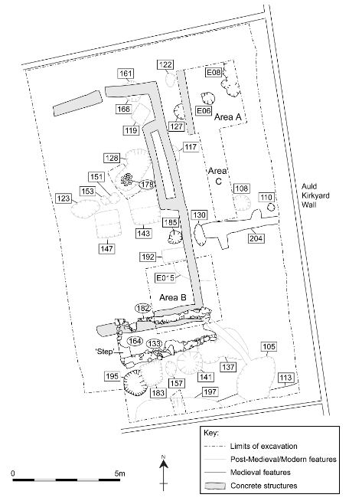

Methods: Evaluation; Excavation
Period(s): Medieval; Post-Medieval; Modern
Dating: -
Feature(s): Pits; Walls
Material Culture: Pottery (Medieval; Post-Medieval; Modern); Metal Artefacts (Modern); Glass (Modern); Clay Tobacco Pipes
Ecofacts: Animal Bone; Charcoal; Shell
Last Update: October 2024 (MM)
Name: Abbot’s Tower, New Abbey
Location: NX 97247 66642
Local Authority: Dumfries and Galloway
NRHE: 65463
LA HER: MDG9165
HES: -
Museum: ?
Reference: Bailey, Allyson 1992 ‘An Excavation at Abbot’s Tower, near New Abbey, Dumfries and Galloway, 1991’, Trans Dum Gall Nat Hist Antiq Soc, 67, 55-60
Summary: The Scottish Urban Archaeological Trust carried out an excavation in August 1991 at the Abbot’s Tower, near New Abbey, Dumfries and Galloway. The aim was to determine the nature and extent of structures and deposits around the tower in advance of restoration works. The excavations revealed at least part of the outline of the barmkin, and the presence, though not the function, of some fairly substantial ancillary structures within it. A small trench within the tower identified a possible floor surface, beneath which was a layer of construction debris. Several fragments of window glass of 16th to 18th-century date were found within the construction debris. The discovery of a byre or stable to the south also revealed that activity continued in this area after the tower went out of use.
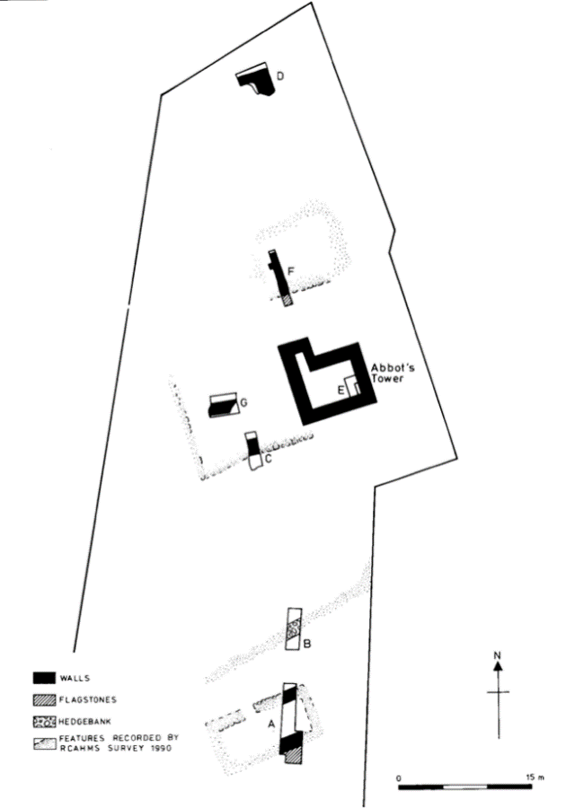

Methods: Excavation
Period(s): Medieval; Post-Medieval
Dating: -
Feature(s): Bank; Barmkin; Buildings; Structures
Material Culture: Glass (Post-Medieval; Modern); Pottery (Modern); Metal Artefacts (Modern)
Ecofacts: Animal Bone
Last Update: August 2024 (MM)
Name: Aird Quarry, Castle Kennedy
Location: NX 09750 60050
Local Authority: Dumfries and Galloway
NRHE: 60767
LA HER: MDG25333
HES: -
Museum: Dumfries and Galloway Museums [Still to identify specific museum]
Reference: Cook, Martin 2006 ‘Excavations of a Bronze Age Roundhouse and associated Palisade Enclosure at Aird Quarry, Castle Kennedy, Dumfries and Galloway’, Trans Dum Gall Nat Hist Antiq Soc, 80, 9-27
Summary: Remains of a prehistoric roundhouse with a palisade enclosure were identified during an archaeological evaluation in advance of a quarry extension in 1999. In accordance with planning conditions an archaeological excavation by AOC Archaeology Group was subsequently undertaken in 2002. The excavation identified two phases of roundhouse construction dating to the Late Bronze Age, each possibly lasting up to 20-40 years. The associated palisade was identified as having a domestic function. Two human cremations were identified alongside burnt animal remains in the southeast quadrant of the site and their placement within structural postholes could suggest a symbolic purpose. The primary role of the enclosure was interpreted as a settlement functioning as part of a self-sufficient economy of both pastoral and arable agriculture. Isolated pits dating to the Neolithic and Iron Age periods were also recorded.
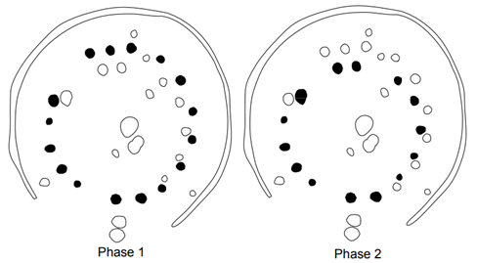

Methods: Aerial Photography; Excavation
Period(s): Neolithic; Bronze Age; Iron Age
Dating: Radiocarbon (6)
Feature(s): Cremations; Cropmark; Roundhouse; Palisade; Postholes; Pits; Ring Ditch
Material Culture: Lithics (Neolithic; Bronze Age); Pottery (Bronze Age)
Ecofacts: Charcoal (Quercus; Corylus); Nutshell (Corylus); Cereal (Triticum); Human Bone (Burnt); Animal Bone (Burnt)
Last Update: June 2024 (LA)

Name: Airylick, Port William
Location: NX 31247 49457
Local Authority: Dumfries and Galloway
NRHE: 62749
LA HER: MDG2421
HES: -
Museum: ?
Reference: Cormack, William F 1981 ‘A Corn-Drying Kiln at Airylick, Port William’, Trans Dum Gall Nat Hist Antiq Soc, 56, 91-99
Summary: The remains of a corn-drying kiln and associated barn, situated northwest of Airylick Farm near Port William, were excavated in 1979 prior to the planned restoration of the barn to a course or two high. A pre-modern settlement was known to sit to the north of the kiln, evidenced by foundations of buildings, small enclosures, two further kilns, and possible indications of an early type mill. Part of this settlement was overlain by the modern House of Elrig and its gardens. Through excavation the kiln was found to be bowl-shaped, with a diameter of 4ft 3ins (1.3m) at the foot and increasing to 6ft (1.8m) in diameter at the existing top. The material is fixed together with clay mortar and also utilises a natural rocky outcrop. The kiln did not have a scarcement for a drying floor to hold the grain, but the sides were deemed rough enough to enable spars to be held across the bowl. A square flue was present entering the bowl from the south. The barn had been built on to the north end of the kiln and was almost square in shape with a maximum length and width of 11ft (3.4m). It was of rough construction with evidence for opposing doorways, possibly for winnowing purposes. The barn’s floor had been of clay, but this had totally disintegrated between the doors where it had been replaced by a rough paved floor. Oat cereal grains were found within the central area of the kiln, and a quantity of carbonised grain was also found trampled into the floor of the barn. The rest of the finds were generally found in the disturbed area of the barn between the two doors. From the pottery, its position relative to Airylick steading and the type of grain, the author states that the kiln is likely to be the one referred to in the Hearth Tax List of 1692. They suggest that that the kiln went out of use around the end of the 18th century, with the barn continuing in use as a general purpose shed for some time after.
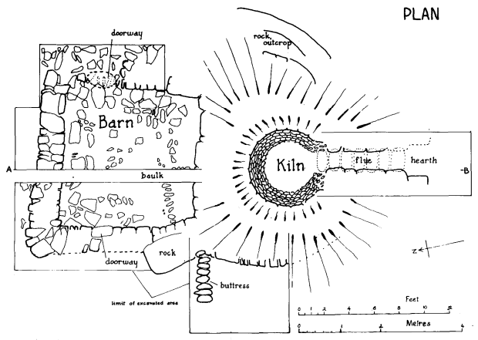

Methods: Excavation
Period(s): Post-Medieval
Dating: -
Feature(s): Corn-Drying Kiln; Building
Material Culture: Carved Stone Fragment; Daub; Glass (Post-Medieval; Modern); Lithics (Mesolithic; Neolithic); Pottery (Post-Medieval; Modern); Metal Artefacts (Post-Medieval; Modern)
Ecofacts: Animal Bone; Cereal (Avena)
Last Update: June 2024 (SC)
Name: Annan Hill
Location: NY 19250 65470
Local Authority: Dumfries and Galloway
NRHE: 66512
LA HER: MDG6884
HES: SM4273
Museum: ?
Reference: Keppie, Lawrence J F 1988 ‘Excavation of a Roman Temporary Camp at Annan Hill, Dumfriesshire, 1985-86’, Trans Dum Gall Nat Hist Antiq Soc, 63, 13-21
Summary: Aerial photography identified a temporary Roman camp atop Annan Hill in 1958. Due to the potential for loss, a trenching exercise revealed and established the alignment of the east defensive ditch of the camp. The work indicated that the site measured approximately 98m north/south by 140m east/west over the ditches, an area of 1.37 hectares (3.38 acres). The single ditch and lack of a gate structure, and indeed of any streets or internal buildings in the limited area examined, seem to preclude identification of the site as a fort. The presence of a little turfwork in the ditch sections could suggest that the camp rampart, while probably of clay, may have been turf-revetted.
Methods: Aerial Photography; Evaluation; Excavation
Period(s): Roman
Dating: -
Feature(s): Ditch; Rampart; Postholes
Material Culture: Glass (Roman)
Ecofacts: Pollen
Last Update: June 2024 (LA)
Name: Ardeer, Stevenston
Location: NS 27116 41931
Local Authority: North Ayrshire
NRHE: 41069
LA HER: 5644
HES: SM3415
Museum: ?
Reference: Hunter, John 1975 ‘Excavation at Ardeer, Ayrshire’, Proc Soc Antiq Scot, 105, 296-301
Summary: A stone-lined passage, now partly under a road, was revealed in 1973 during building operations. The passage was lined with corbelled drystone walling, roofed with capstones, and led into a natural cave. The visible remains suggested a souterrain. It had been partially excavated in 1960 and then filled in with slag and rubble. Remains of a dressed stone frame for an iron grille over a hole in the cave roof suggested its use as a grotto in the 19th century. The passage, cut into a 30ft (9.14m) raised beach, was between 13m and 16m long; its width varied from 1.55m to 1.20m, and height from 1.7m to 2.4m due to the uneven rock floor. The capstones were 1.0m to 1.5m below the ground surface. Some areas of undisturbed stratified deposits were found. These contained evidence of occupation – a hearth with iron slag, bones and a fragment of glass (possibly Roman). It was concluded that although there was no decisive evidence to date the site, the overall pattern of findings, both as regards the structure itself and the occupation refuse, conformed to the Angus souterrains, the natural cave replacing the terminal bulge often found. The absence of known souterrains in southwest Scotland at the time made it difficult for the excavators to accept this conclusion, however. Furthermore, there was no evidence of the deliberate dismantling or infilling of the underground structure after it fell out of use which had been noted at other souterrain sites.
Methods: Excavation
Period(s): Iron Age
Dating: -
Feature(s): Hearth; Souterrain (pos)
Material Culture: Glass (pos Roman); Industrial Residue
Ecofacts: Animal Bone; Antler; Charcoal (Quercus)
Last Update: August 2024 (MM)
Name: Arran High School
Location: NS 02253 30754
Local Authority: North Ayrshire
NRHE: 273891
LA HER: 61659
HES: -
Museum: Isle of Arran Heritage Museum
Reference: Rees, Thomas and Shaw, Rebecca forthcoming ‘An Early Bronze Age Cemetery at Arran High School, Lamlash’
Summary: Excavations at Arran High School recorded an Early Bronze Age cemetery comprising four cist burials and up to six urned cremations within pits. Lying slightly northwest of the cemetery, but separate, was a contemporary pyre. A range of items were recovered from the graves, including two flint serrated knives and six pottery vessels. The latter comprised three Collared Urns, a Cordoned Urn, a Food Vessel and a small decorated bowl. Radiocarbon dates obtained from human skeletal material indicated two main phases of burial on the site, spanning the second millennium BC. The types of grave goods used and the form of burial varied across both phases, demonstrating a lack of consistency in the burial rite despite repeated use of the same cemetery.
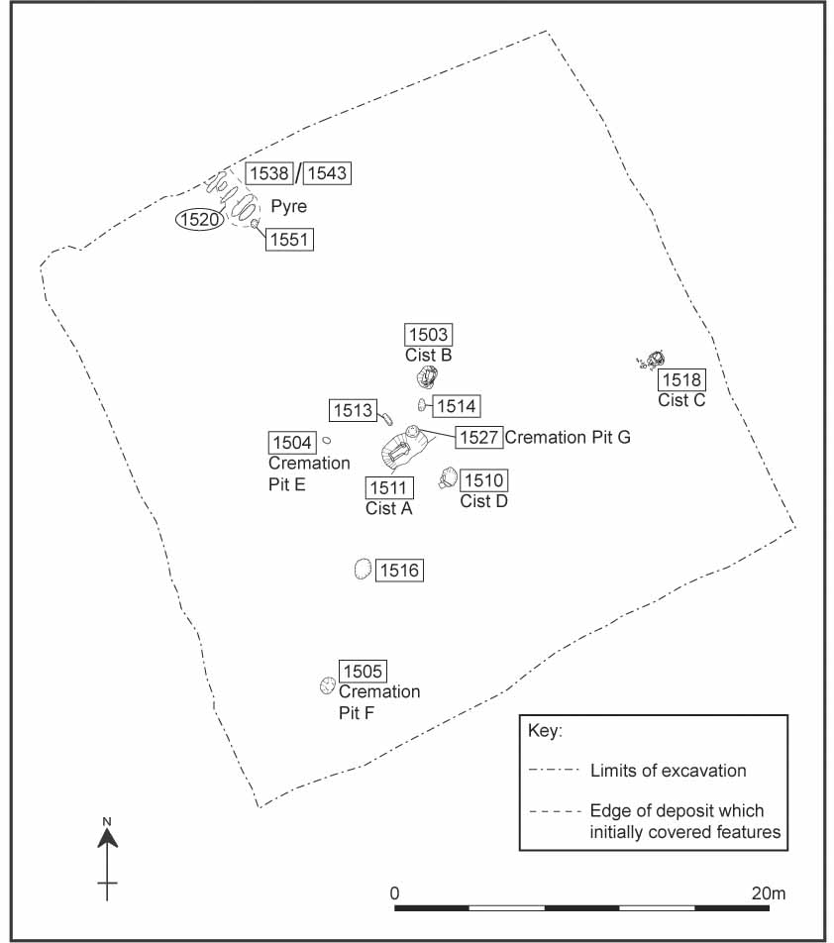

Methods: Evaluation; Excavation
Period(s): Bronze Age
Dating: Radiocarbon (7)
Feature(s): Cremations; Short Cists; Structure; Postholes; Pits
Material Culture: Pottery (Bronze Age; Modern); Lithics (Bronze Age)
Ecofacts: Charcoal (Corylus; Alnus; Salix; Betula); Human Bone (Burnt)
Last Update: October 2024 (MM)
Name: Auchareoch
Location: NR 99550 24750
Local Authority: North Ayrshire
NRHE: 39657
LA HER: 4245
HES: -
Museum: ?
Reference: Fairhurst, H 1981 Exploring Arran’s Past, Central Press: Glasgow
Affleck, T L, Edwards, K and Clarke, A 1988 'Archaeological and palynological studies at the Mesolithic pitchstone and flint site of Auchareoch, Isle of Arran', Proc Soc Antiq Scot, 118, 37-59
Edwards, K J 1996 ‘The contribution of Tom Affleck to the study of the Mesolithic of Southwest Scotland’ in Pollard, T and Morrison, A (eds) The Early Prehistory of Scotland: 108-22. Edinburgh University Press: Edinburgh
Summary: Fieldwalking the inland kame terrace by the Kilmory Water at Auchareoch that was being quarried revealed hearths and lithics including microliths (Fairhurst 1981, 10). A project led by Affleck (Affleck et al 1988) in 1985 undertook the controlled recovery of lithics across the dozed summit of the kame showing a general density of 30 lithics per m² reaching over 80 lithics in some locations. In total 4,417 flint (90%) and pitchstone (10%) pieces were found, with over a quarter of the flint burnt. The lithic assemblage included cores (platform), flakes, blades, and retouched tools (including backed blades, scrapers, awls and microliths). From numerous hearths and a pit, carbonized hazelnut shells were recovered (hazelnut shells dated from pit and hearth gave dates of 8060 ± 90 bp (OxA-1601) and 7300 ± 90 bp (OxA-1599) respectively while oak charcoal dated to 7870 ± 90 bp OxA-1600). The extent and character of the occupation area are assessed and shown to be extensive (300-400m²). The environmental data demonstrated within the limits imposed by soil pollen and charcoal studies possible hunter-gathering and agricultural impacts before soil deterioration and peat growth.
Methods: Fieldwalking; Excavation
Period(s): Mesolithic
Dating: Radiocarbon (3)
Feature(s): Hearth; Pit; Lithic Working Site
Material Culture: Lithics (Mesolithic)
Ecofacts: Nutshell (Corylus); Unidentified Bone (Burnt); Pollen; Charcoal (Quercus)
Last Update: May 2025 (TR)
Name: Auchenwinn Bridge, Maybole
Location: NS 30250 09020
Local Authority: South Ayrshire
NRHE: 296416
LA HER: 61751; 54094
HES: -
Museum: ?
Reference: Becket, Alastair and MacGregor, Gavin 2010 ‘Forest grazing and seaweed foddering: early Neolithic Occupation at Maybole, South Ayrshire’, Proc Soc Antiq Scot, 139, 105-122
Summary: A group of Early Neolithic features, probably related to the cooking of food, was excavated by Glasgow University Archaeological Research Division (GUARD) near Maybole, South Ayrshire. Particularly significant was the wide range of finds that had been deposited within some of the features, including carbonised ovicaprid (probably goat), faecal pellets, a fragment of a Group VI Great Langdale stone axehead, burnt human bone, a fragmented cylindrical stone object, an assemblage of struck lithics (including pitchstone) and an assemblage of Carinated Bowl pottery. The presence of the carbonized goat pellets from such an early date is particularly significant and allowed the opportunity to examine the interrelationships of human, animal and the environment in which they existed at a crucial point in the development of a new way of life. Several features also contained considerable amounts and varieties of carbonised botanical remains, providing a broader insight into the landscape where these features were found. Analysis of these remains, the pits and the possible hearth all suggest that there had been a short phase of occupation, radiocarbon dated to 3780–3650 cal BC.
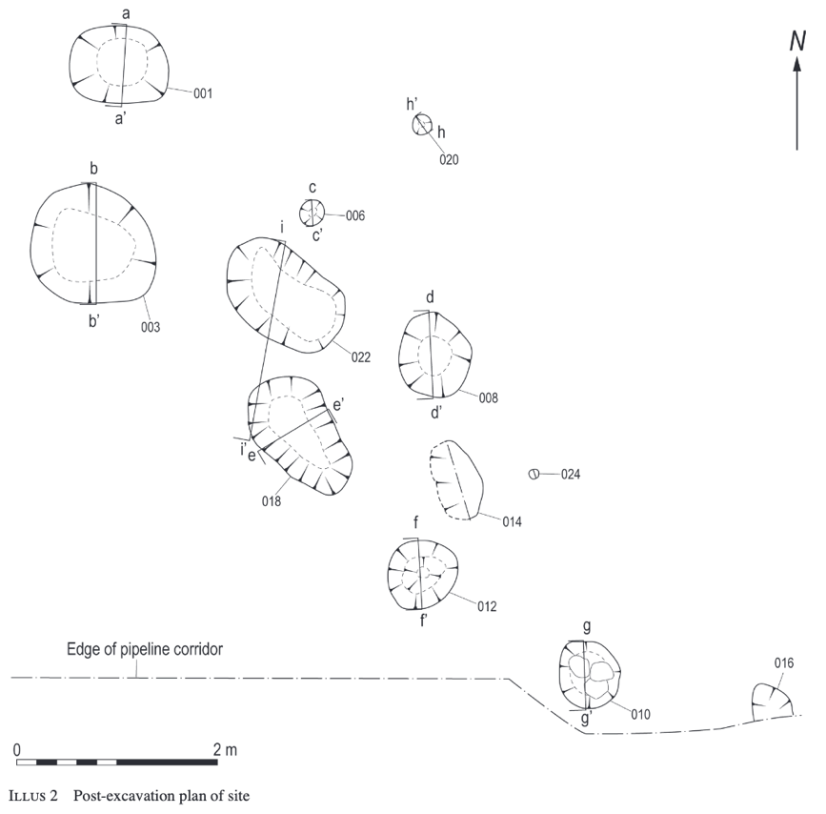

Methods: Monitoring; Excavation
Period(s): Neolithic
Dating: Radiocarbon (2)
Feature(s): Pits; Stakeholes; Hearth (pos)
Material Culture: Coarse Stone Artefacts (Neolithic); Lithics (Neolithic); Pottery (Neolithic)
Ecofacts: Cereal (Hordeum; Triticum); Charcoal (Quercus; Alnus; Corylus; Salix; Betula); Apple Seeds; Seaweed; Weed Seeds; Faecal Remains; Human Bone (Burnt); Nutshell (Corylus)
Last Update: June 2024 (MM)
Name: Auchrannie, Arran
Location: NS 00785 35941
Local Authority: North Ayrshire
NRHE: 215297
LA HER: 42974
HES: -
Museum: National Museums Scotland
Reference: Mudie, George 2007 ‘Excavations on the site of a late Iron Age roundhouse and souterrain, Glen Cloy, Brodick, Isle of Arran’, Scot Archaeol J, 29.1, 1-29
Williamson, Claire 2017 ‘A dark and mysterious place: excavations of an Iron Age settlement at Auchrannie, Brodick’, Scot Archaeol J, 39, 1-34
Summary: Archaeological monitoring of a hotel and leisure development site in Glen Cloy, Isle of Arran in 2001 revealed the presence of a well-preserved, substantial roundhouse and an associated complex souterrain. The roundhouse and souterrain were partly excavated in 2001 with a subsequent full excavation required in 2014 when the development was expanded. The 2001 excavation revealed that the roundhouse had a possible construction date in the late 2nd or early 1st century BC and had similarities to earlier Bronze Age structures discovered on the west coast of Arran at Tormore. There was evidence for on-site metalworking and the fabrication of cannel coal artefacts. The finds recovered, including two cannel coal bracelets and a bronze spiral finger ring, suggested that this was a prestigious high-status settlement at the mouth of Glen Cloy. The subsequent excavation in 2014 revealed that the southern half of the roundhouse had been badly truncated through agricultural land use, while the souterrain passages remained largely intact. The latter revealed evidence for timber- and stone-lined sections, with a group of overlapping pits and shallow passages at one end. While one of the souterrain passages appeared to have been deliberately infilled during, or not long after, the 2nd century AD, the other was not backfilled until the medieval period, possibly being left open as a void until this time. Other dates also pointed to the continued reuse of portions of the site on a much smaller scale throughout later periods.
Methods: Monitoring; Excavation; Soil Micromorphology; XRF Analysis
Period(s): Bronze Age; Iron Age
Dating: Radiocarbon (9)
Feature(s): Roundhouse; Postholes; Pits; Souterrain; Hearth; Cultivation
Material Culture: Pottery (Iron Age); Lithics (Mesolithic; Neolithic; Bronze Age; Iron Age); Coarse Stone Artefacts (Iron Age); Industrial Residue; Daub; Metal Artefacts (Iron Age); Cannel Coal Artefacts (Iron Age)
Ecofacts: Animal Bone (Burnt); Cereal (Avena; Hordeum; Triticum); Charcoal (Quercus; Corylus; Betula; Calluna); Nutshell (Corylus); Weed Seeds
Last Update: January 2025 (LA)
Name: Barassie, Troon
Location: NS 33880 32540
Local Authority: South Ayrshire
NRHE: 339465
LA HER: 94808; 3817; 4871
HES: -
Museum: ?
Reference: Arabaolaza, Iraia 2017 ‘Prehistoric settlement and ritual activities at Barassie, South Ayrshire’, Scot Archaeol J, 39, 35-94
Summary: Between 2008 and 2012, archaeological excavations on agricultural land at Barassie near Troon revealed a palimpsest site, which included Mesolithic pits, Neolithic pits and structures and Bronze Age pits and boundary ditches. Confirmed by radiocarbon dates, the Mesolithic remains consisted of two groups of pits at the southeast end of the site, including two likely hearths, which contained a mix of charcoal, burnt bone and lithics. One of the hearths also contained over 5,000 fragments of carbonized hazelnut shell, and it was suggested that the collection and roasting of hazel nuts may have been the primary motive for short, ad-hoc, visits to the site in this period. Early Neolithic settlement was evidenced by fragmentary structural remains: one defined by a curved ditch and two others by postholes. They produced sherds of early Neolithic carinated bowls, contemporary lithic artefacts (including Arran pitchstone and Cumbrian tuff) and had associated radiocarbon dates. Based on material culture and radiocarbon dates, a small number of pits (including one hearth) and a posthole were dated to the middle or late Neolithic period. The finds from these comprised lithics and pottery, including sherds from Impressed Ware and Beaker vessels. The recovery of exotic finds from both the early and later Neolithic features suggested that Barassie was part of a regional and longer-distance system of exchange that promoted action of beliefs marked by artefacts deposited in pits. The Bronze Age remains on site were scattered but included a possible fire pit and two parallel ditches which measured between 73 and 86m long. Radiocarbon dated to the middle and late Bronze Age, the two ditches appear to have acted as open boundary ditches, one possibly representing a later modification of the other. The presence of the boundary ditches suggested that the land belonged to individuals who marked the edges of their territory or field, and by doing so, they marked a degree of permanence during this period. Evidence of a possible single cremation burial was also represented by the presence of an unstratified plain urn, identified as potentially Bronze Age in date.
Methods: Evaluation; Excavation
Period(s): Mesolithic; Neolithic; Bronze Age
Dating: Radiocarbon (14)
Feature(s): Cremation (pos); Ditches; Hearths; Pits; Postholes; Stakeholes; Structures
Material Culture: Lithics (Mesolithic; Neolithic); Pottery (Neolithic; Bronze Age)
Ecofacts: Animal Bone (Burnt); Charcoal (Alnus; Corylus; Quercus; Salix; Ulmus); Nutshell (Corylus)
Last Update: October 2024 (MM)
Name: Barhobble, Mochrum
Location: NX 31040 49409
Local Authority: Dumfries and Galloway
NRHE: 62744
LA HER: MDG2416
HES: SM7546
Museum: Dumfries Museums
Reference: Cormack, William F 1995 ‘Barhobble, Mochrum, Excavation of a Forgotten Church Site in Galloway’, Trans Dum Gall Nat Hist Antiq Soc, 70
Summary: Small excavations between 1984 and 1994 were undertaken at the site of Barhobble, thought to be the original source location for 10th or 11th century cross fragments reused within structures in the northern part of Mochrum Parish. The excavations disclosed substantial remains of a small 12th century stone-built church, which had a few internments placed in its nave. The church had been built over an existing burial ground from which further cross fragments recovered had clearly originated. The large proportion of child burials indicated that this was for the cemetery of a lay population, as opposed to monastic, and some of the burials contained grave goods. Earlier buildings (possibly from the 11th century) included a timber-built oratory and a substantial structure with stone side walls and postulated timber gables – possibly an earlier church. The structures and finds from the site pointed to strong Norse traditions in the mixed Celto-Norse population in Galloway at this period. They also showed some mixing of Christian and Pagan traditions. After a short period of disuse, the 12th-century church was converted to a chapel with a floruit in the 13th century. The west end appears to have been used as a dwelling, presumably for a chaplain or other incumbent of the chapel with a cooking place outside. The site was then unoccupied for over four centuries until a two roomed-cottage, with a smithy in an annexe to the west, was constructed to the west of the ruined chapel. This appears to have been constructed in the second half of the 18th century but was abandoned prior to the 1st edition Ordnance Survey map surveyed in 1848.
Methods: Excavation; Phosphate Analysis
Period(s): Early Medieval; Medieval; Modern
Dating: Radiocarbon (7); Thermoluminescence
Feature(s): Buildings; Burials; Enclosure; Pits; Postholes; Hearths; Stakeholes; Structures
Material Culture: Daub; Pottery (Medieval); Metal Artefacts (Medieval); Carved Stone Fragments (Medieval); Coarse Stone Artefacts (Medieval); Lithics; Glass; Jet Artefact; Coins (Early Medieval; Medieval; Post-Medieval; Modern); Structural Timbers; Quartz
Ecofacts: Animal Bone; Animal Bone (Burnt); Charcoal (Alnus; Betula; Corylus; Quercus; Sorbus); Human Bone; Shell; Weed Seeds
Last Update: June 2024 (SC)
Name: Barsalloch (Pate’s Port)
Location: NX 34380 42110
Local Authority: Dumfries and Galloway
NRHE: 62827
LA HER: MDG2492
HES: -
Museum: Dumfries Museum
Reference: Coles, J M 1964 ‘New Aspects of Mesolithic Settlement in South-West Scotland’, Trans Dum Gall Nat Hist Antiq Soc, 41, 67-98
Cormack, W F 1970 ‘A Mesolithic site at Barsalloch, Wigtownshire’, Trans Dum Gall Nat Hist Antiq Soc, 47, 63-80
Summary: Pate’s Port, Barsalloch, on a raised post-glacial shoreline, was targeted for excavation in 1967 and 1969 (Cormack 1970) after lithic analysis (Coles 1964) from coastal fieldwalking over 1962-64 and excavation of nearby Low Clone South. Marine shell was noted on the surface. A palaeosol was revealed by grid excavation containing lithics, pits, hearths, stone settings and charcoal (dated to 6100 ± 110 bp (GaK 1601)). The four pits lay equidistant on an arc, and were considered hearths. In total, some 691 lithics were recovered, wholly flint except one pitchstone and one chert piece; they included cores (platform), rejuv flakes, flakes, blades, retouched tools (including backed blades, burins, scrapers, reamers, tranchets, awls and microliths (8)) and hammerstones.
Methods: Fieldwalking; Excavation
Period(s): Mesolithic
Dating: Radiocarbon (1)
Feature(s): Hearth; Pit; Stakehole
Material Culture: Lithics (Mesolithic)
Ecofacts: Charcoal; Shell
Last Update: May 2025 (TR)
Name: Beckton Farm, Lockerbie
Location: NY 13050 82450
Local Authority: Dumfries and Galloway
NRHE: 66818; 72681
LA HER: MDG7171; MDG5236
HES: -
Museum: Dumfries Museum (1963 material)
Reference: Cormack, W F 1963 'Prehistoric site at Beckton, Lockerbie', Trans Dum Gall Nat Hist Antiq Soc, 41, 111-15
Pollard, T 1997 ‘Excavation of a Neolithic settlement and ritual complex at Beckton Farm, Lockerbie, Dumfries & Galloway’, Proc Soc Antiq Scot, 127, 69-121
Summary: During construction of the A74 in the field east of the farmhouse at Beckton Farm a circular palisaded enclosure, formed by a stone-packed continuous trench, with entrance to the southeast was observed. The interior contained a series of pits and a black occupation deposit in one area. Pottery was recovered from the occupation deposit and a pit, this included several Grooved Ware sherds (Cormack 1963). Postulated as a Neolithic enclosure, if it was a coherent single site, was wholly lost. Subsequent fieldwalking by Cormack recovered a small lithic assemblage (nos 34) of flint and pitchstone from the ridge the farm lies on. Evaluation of the ridge in advance of the M74 motorway extension recovered more lithics (nos 20) (mainly flint including an oblique arrowhead and a microlith), Neolithic pottery (Western Neolithic Ware) and a ditch. Subsequent excavation (Pollard 1997) revealed a second Neolithic settlement to the north of the first. This included two poorly defined structures, possibly small houses, one formed by a clay-based floor bounded by stakeholes [136] while the second [143] was dated to the early Neolithic by an RC date. A third clear structure [111] was formed by a penannular ring ditch enclosing a 3.4m diameter area. The ring ditch contained postholes and stakeholes, with an entrance to the east-southeast. A Grooved Ware sherd from the ring ditch provides a late Neolithic terminus post quem for this structure. Two four-post structures were also excavated. A stretch of curvilinear ditch, various pits and post-holes were also present. Some pits were fire pits, two provided Neolithic RC dates, the fire pits were external to the structures with one having a clay-lined trough form with a possible flue. Finds included a small assemblage of pottery (coarse ware and Grooved Ware, the latter mainly deposited in pits, 3 of which had RC dates recovered), coarse stone tools (hammer stones, pounders, rubbers, cup-marked stones and a saddle quern) and lithics (nos 116) of flint and pitchstone. The presence of cremated human bone and animal bone in one of the Grooved Ware pits may represent ritual activity. The radiocarbon dates suggest a sequence of activity stretching from the mid-4th to the mid-3rd millennium BC. The recovery of microliths within the lithic assemblage suggests residual material from the Mesolithic, though the author hints that a Neolithic provenance may be possible.
Methods: Fieldwalking; Geophysical Survey; Evaluation; Excavation; Soil Micromorphology; Phosphate Analysis; Magnetic Susceptibility Survey
Period(s) : Mesolithic; Neolithic
Dating: Radiocarbon (6)
Feature(s): Posthole; Pit; Stakehole; Hearth; Ring Ditch; Structure; Four-Poster Structure; Kiln (pos)
Material Culture: Lithics (Mesolithic; Neolithic); Pottery (Neolithic); Coarse Stone Artefacts (Neolithic)
Ecofacts: Human Bone (Burnt); Animal Bone; Charcoal (Quercus; Corylus; Prunus; Alnus; Betula; Salix; Ulex); Nutshell (Corylus); Cereal (Hordeum)
Last Update: June 2024 (TR)
Name: Blairbuy, Glasserton
Location: NX 35958 42053
Local Authority: Dumfries and Galloway
NRHE: 346511
LA HER: MDG25700
HES: -
Museum: ?
Reference: Bailie, Warren 2013 ARO6: Preparing for death: excavations at Blairbuy, Dumfries and Galloway in 2012, Archaeology Reports Online
Summary: Archaeological investigations at Blairbuy Farm, Dumfries and Galloway revealed evidence that cists in the Bronze Age may have been tailored for individuals during their lifetime, possibly from early in life. During an investigation of a cist containing a juvenile inhumation, accidentally damaged by ploughing in April 2012, two additional empty cists were uncovered. The cists were constructed differently in terms of both material and form. Samples from all three and the surrounding subsoil were tested using multi-element analysis and this implied that the two empty cists had never been used for the burial of human remains. The skeletal remains were that of a juvenile individual with an age estimate of approximately nine to twelve years old. This child suffered malnutrition, indicated by dental enamel hypoplasia (DEH) and cribra orbitalia, both childhood stress indicators. A radiocarbon date of 2027 to 1886 cal BC (2σ) was obtained from the left ulna, placing this individual’s death in the early Bronze Age period.
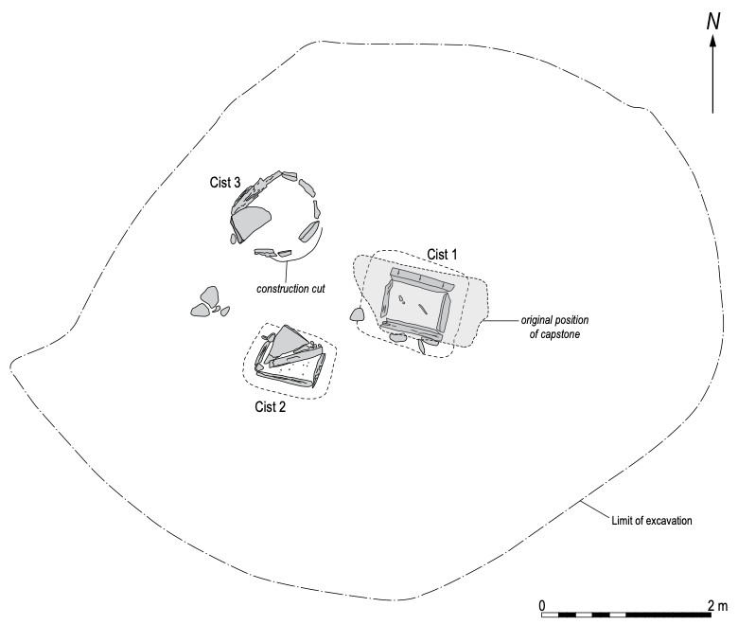

Methods: Elemental Analysis; Excavation
Period(s): Bronze Age
Dating: Radiocarbon (1)
Feature(s): Cists
Material Culture: -
Ecofacts: Human Bone
Last Update: October 2024 (MM)
Name: Blairhall Burn, Amisfield
Location: NX 99896 84664
Local Authority: Dumfries and Galloway
NRHE: 78527; 78526; 78525; 78524; 78523
LA HER: MDG5085; MDG4966; MDG6223; MDG6224; MDG5087
HES: -
Museum: ?
Reference: Strachan, Richard, Ralston, Ian and Finlayson, Bill 1999 ‘Neolithic and later prehistoric structures, and early medieval metal-working at Blairhall Burn, Amisfield, Dumfriesshire’, Proc Soc Antiq Scot, 128, 55-94
Summary: The Centre for Field Archaeology was commissioned by Irish Gas to undertake archaeological excavations during the construction of the Southwest Scotland Gas Interconnector Pipeline, approximately 2km north of the village of Amisfield, near Dumfries. Five separate areas of archaeological interest were identified, providing evidence for a range of activities from the later Neolithic to the early medieval period, with a hiatus of activity from the later Bronze Age for almost two thousand years. The earliest activity on site was represented by two pits radiocarbon dated to the Neolithic period, which also contained pottery and a flake from a polished axehead. Most of the excavated evidence appeared to represent settlement and associated activities from the Bronze Age, broadly occurring within the second millennium BC. This evidence included two burnt mounds and three principal structures: two double-ring roundhouses (one with a projecting porch entrance) and the remains of a ring-groove structure, which may have formed part of a platform house. Finds from these features included saddle querns, pottery and a cannel coal ‘napkin-ring’. The latest activity on site was represented by a scatter of pits, a bowl-shaped hearth and a posthole. These features produced a large quantity of slag and a radiocarbon date of AD 870–1030, indicating a relatively short-term and non-intensive phase of iron working in the early medieval period. While the radiocarbon dates are broadly supported by the sparse artefactual evidence recovered, phasing within the sequence is less structurally specific: the internal phasing of this sequence does not suggest a neat succession of structural types.
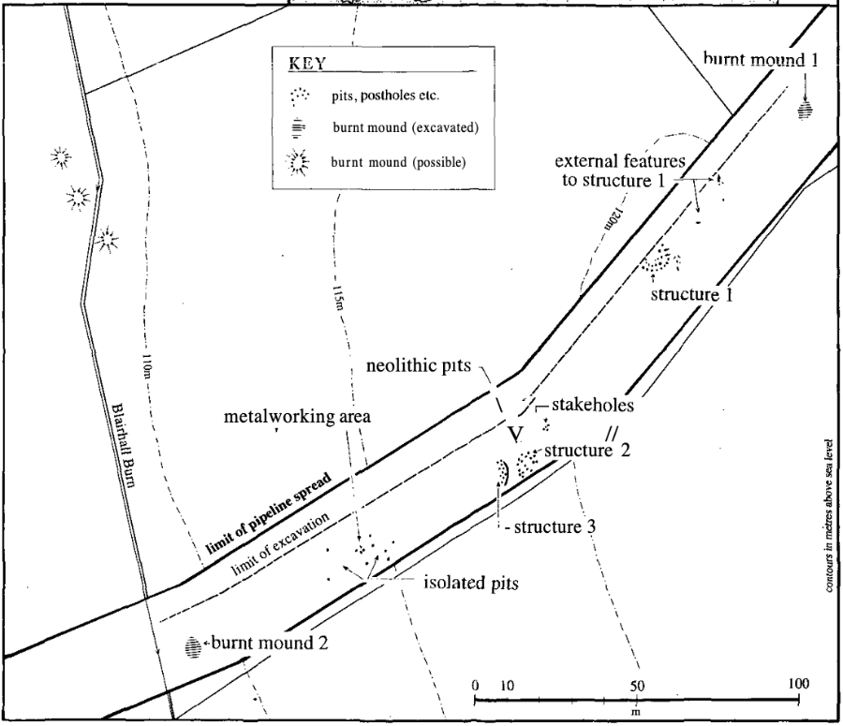

Methods: Fieldwalking; Excavation; Pollen Analysis
Period(s): Neolithic; Bronze Age; Iron Age; Early Medieval
Dating: Radiocarbon (11)
Feature(s): Burnt Mounds; Postholes; Stakeholes; Pits; Hearth; Roundhouses
Material Culture: Pottery (Neolithic; Bronze Age); Lithics (Neolithic); Coarse Stone Artefacts (Neolithic; Bronze Age); Industrial Residue; Daub; Cannel Coal Artefact (Bronze Age); Metal Artefacts
Ecofacts: Unidentified Bone (Burnt); Charcoal (Quercus, Betula, Corylus, Alnus); Cereal (Hordeum); Pollen; Fungal Spores
Last Update: January 2025 (CW)
Name: Boonies, Westerkirk
Location: NY 30490 90039
Local Authority: Dumfries and Galloway
NRHE: 67818
LA HER: MDG8119
HES: -
Museum: ?
Reference: Jobey, George 1975 ‘Excavations at Boonies, Westerkirk, and the nature of Romano-British settlement in eastern Dumfriesshire’, Proc Soc Antiq Scot, 105, 119-140
Summary: This enclosed settlement is situated on the edge of a river terrace some 15m above the River Esk, immediately west of Boonies. An area of about 0.07ha (0.17 acres) is enclosed by a bank, still standing to a height of about 2m, except along the edge of a river scarp where only a low mound is visible; the entrance is in the east. Most of the material for the bank was obtained from an external ditch, now only apparent in places as a differential growth in pasture. Before excavation by Jobey in 1973-4, the southeast half of the interior appeared to be occupied by a slightly scooped yard, though no house sites could be seen in the remaining (upper) sector. Jobey's excavations showed that the enclosure bank consisted of mixed earth and stone, 5m to 6m apart, though the width along the crest of the scarp was probably no more than 2.5m. Where excavated, the ditch was 4m wide, narrowing to 2.5m wide near the entrance; the depth was 1.25m. A radiocarbon date of 108 ±47 AD was obtained from carbonised wood sealed by the remains of the bank near House 12. Traces of thirteen round, timber-built houses (ring-ditch type) were found, many of them representing successive structural phases. A radiocarbon date of 1047 ±55 AD was obtained from material taken from a pit within House 11. No structures associated with this pit were found. Among the artefacts found were pieces of quernstones, stone pounders, perforated stones, seven sherds of local pottery, three sherds of Roman pottery (possibly of 1st to early 2nd-century date) a fragment from a glass bracelet or pendant (Kilbride-Jones type 3A), a corroded penannular brooch (Fowler's type A3) and modern material. For much of the time, this site was a homestead, with a single house; in the final phase, a maximum of five houses co-existed.
Methods: Excavation
Period(s): Iron Age
Dating: Radiocarbon (2)
Feature(s): Enclosure; Hearths; Pits; Postholes; Roundhouses
Material Culture: Glass (pos Roman); Pottery (Iron Age; Roman; Modern); Coarse Stone Artefacts (Iron Age); Metal Artefacts (Iron Age; Modern)
Ecofacts: Animal Bone (Burnt); Charcoal
Last Update: August 2024 (MM)

Name: Brydekirk, Annan
Location: NY 18530 71107
Local Authority: Dumfries and Galloway
NRHE: 66722
LA HER: MDG12201
HES: SM12185
Museum: ?
Reference: Crowe, Chris 1984 ‘Excavation at Brydekirk, Annan, 1982-1984’, Trans Dum Gall Nat Hist Antiq Soc, 59, 33-40
Summary: In July 1982 an excavation was commenced at Brydekirk, Dumfries. There is no documentary evidence for the site, but the Ordnance Survey and local tradition show St. Bryde’s Kirk here. A quarter of a mile to the north is St Bryde’s Well on the banks of the River Annan. The author believed that a dedication to St Bridget was of sufficient interest to warrant investigation to see if the site had any connection with Irish monastic sites in Scotland of the 6th century. The name may also show a Christianising of a pagan Celtic goddess ‘Brighda’ and a reuse of the site of a pagan place of worship. It is generally accepted that the Bryde-Bridget transfer is correct, but it may represent a 12th-century popularising rather than an Irish tradition. The place-name evidence is sparse – ‘Bridechapell’ (1507), Bridkyrk (1517) but confirms that this is the site which gives the place its name. There are important St Bridget dedications at Durisdeer where early sculpture has been found, at Moresby (Cumbria) (the site of the principium of a Roman fort) and at Kirkbride (Cumbria) where there is a similar relationship to a Roman fort. The chapel ruin lies on a small hillock about 50m north of Brydekirk Mains farm. The excavation found the present structure was occupied from the 12th century to the 16th century with the building being patch pointed and kept in repair until being allowed to fall down in the mid 16th century. The building was surrounded by a substantial wall of which only the rubble core remains, the rest having been robbed for building stone. The present building rests on earlier stone remains. The east wall and west wall were founded through a large area of abandoned industrial waste in the form of clay and charcoal built up over a number of years. This process of industry may have been connected with an earlier building, with the smoother and whetstone indicating a monastic workshop during the medieval period.
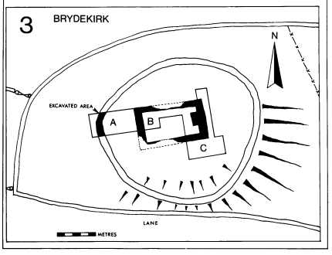
Methods: Excavation
Period(s): Mesolithic; Medieval
Dating: -
Feature(s): Building
Material Culture: Lithics (Mesolithic); Pottery (Roman; Medieval); Coins (Medieval); Coarse Stone Artefacts; Metal Artefacts; Industrial Residue
Ecofacts: -
Last Update: June 2024 (SC)
Name: Burnfoot Plantation, Dowglen Hill
Location: NY 33750 89170
Local Authority: Dumfries and Galloway
NRHE: 67612
LA HER: MDG7912
HES: -
Museum: Dumfries Museum
Reference: Cowie, Trevor G, Masters, Lionel J and Harman, M 1981 ‘An Urn Burial from Burnfoot Plantation Dowglen Hill, Westerkirk’, Trans Dum Gall Nat Hist Antiq Soc, 56, 31-37
Summary: In 1977, a rescue excavation was conducted on the discovery of an inverted collared urn eroding out the top of a steep slope in the Burnfoot plantation on the south side of Downglen Hill, Westerkirk. The urn sat at a depth of 350mm below the surface and there were no indications of a cist at the site and no surviving traces of a pit. The urn contained the cremated remains of a young adult (possibly female), a bone pin and a flint point. The urn itself had cord-incised decoration across its upper half and was identified as being between approximately 2000 and 1400 BC in date. The decoration was atypical amongst urns of this type recorded from the region. The discovery at Burnfoot extended the distribution of cinerary urns in the southwest towards Upper Eskdale, an area of Dumfriesshire that had otherwise produced relatively few recognisably ‘Bronze Age’ sites or finds by that time.
Methods: Excavation
Period(s): Bronze Age
Dating: -
Feature(s): Cremation
Material Culture: Bone Artefact; Pottery (Bronze Age); Lithic
Ecofacts: Human Bone (Burnt)
Last Update: June 2024 (LA)
Name: Carghidown
Location: NX 43560 35070
Local Authority: Dumfries and Galloway
NRHE: 63132
LA HER: MDG2770
HES: -
Museum: ?
Reference: Toolis, Ronan 2008 ‘Intermittent occupation and forced abandonment: excavation of an Iron Age promontory fort at Carghidown, Dumfries and Galloway’, Proc Soc Antiq Scot, 137, 265-318
Summary: Excavations at Carghidown demonstrate sporadic occupation of this promontory fort over a short period, during the late first millennium BC or early first millennium AD. With an external rampart, a singular possible two-storey roundhouse was identified with the settlement interior split into roofed zones and open zones. The analysis of lead beads from this settlement adds support to growing evidence for copper mining in this area of Galloway at the time and suggests that, whether their deposition be intentional votive offering or accidental loss, the inhabitants were of some status within the local social hierarchy. The excavation also demonstrates that the site was only formally enclosed during the latter stages of its occupation and that within a year or two of this act of enclosure the ramparts were violently thrown down, the repair and construction of buildings within the settlement was abruptly halted and occupation ceased.
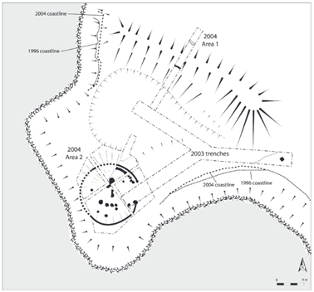

Methods: Aerial Photography; Gradiometry; Topographic Survey; Excavation; Isotope Analysis; Soil Micromorphology
Period(s): Iron Age
Dating: Radiocarbon (5)
Feature(s): Bank; Postholes; Roundhouse; Pit; Post-Pad; Rampart
Material Culture: Coarse Stone Artefacts (Iron Age); Metal Artefacts (Iron Age; Modern); Glass (Modern); Pottery (Modern)
Ecofacts: Charcoal (Corylus; Fraxinus)
Last Update: June 2024 (LA)
Name: Carlochan, Crossmichael
Location: NX 75771 67475
Local Authority: Dumfries and Galloway
NRHE: 64581
LA HER: MDG4613
HES: -
Museum: ?
Reference: Masters, Lionel 1977 ‘Excavation of the Carlochan Round Cairn, Crossmichael, Stewartry District’, Trans Dum Gall Nat Hist Antiq Soc, 52 (1976-77), 44-55
Summary: A 2nd millennium round cairn of 25m diameter at Carlochan, Castle Douglas, was partially excavated prior to its destruction by the Dumfries and Galloway Water Board. The cairn had been robbed in the late 18th century, when a cist and bronze dagger were recorded, leaving only one-third of the cairn intact. Excavation failed to reveal any further burials and demonstrated that the mass of the cairn, as it appeared before excavation, was made up of field clearance. During the destruction of an unexcavated part of the site, a cordoned urn, inverted over a cremation deposit and pygmy vessel, was discovered and excavated. A small flint, chert and pitchstone flakes, burnt flint and a burnt flint scraper were also recovered.
Methods: Excavation
Period(s): Bronze Age
Dating: -
Feature(s): Bank; Cairn; Cremation; Pit
Material Culture: Pottery (Bronze Age); Lithics
Ecofacts: Charcoal; Human Bone (Burnt)
Last Update: August 2024 (MM)

Name: Carronbridge, Thornhill
Location: NX 86934 97749
Local Authority: Dumfries and Galloway
NRHE: 65175; 65197; 71825; 72111
LA HER: MDG5136; MDG5653; MDG5679; MDG4651
HES: SM4093
Museum: ?
Reference: Johnston, Daniel A 1995 ‘Carronbridge, Dumfries and Galloway: the excavation of Bronze Age cremations, Iron Age settlements and a Roman camp’, Proc Soc Antiq Scot, 124, 233-291
Owen, Olwyn and Welander, Richard 1996 ‘A traveller’s end? – an associated group of Early Historic artefacts from Carronbridge, Dumfries & Galloway’, Proc Soc Antiq Scot, 125, 753-770
Summary: Cropmarks of a square, double-ditched Iron Age/Romano-British enclosure (A), a Roman temporary camp (B) and another sub-rectangular enclosure (C) were excavated in advance of road building. All the monuments were plough damaged. Enclosure A was the longest lived of the three excavated enclosures. Radiocarbon dates suggest intermittent pre-enclosure activity in the Bronze Age and Iron Age. There were then three main enclosure phases: the first enclosure phase probably took place during the last century BC, while the last phase ended at some point between the 2nd century and 5th century AD. The enclosure contained six intersecting circular buildings, one of which was surrounded by a large ditch and three large sunken features with complex, charcoal-rich fills. A cobbled surface (probably a Roman road) crossed its southeast corner. The use of Enclosure A spanned the main periods of Roman involvement in South West Scotland. A penannular brooch, fragmentary sword blade and part of a sickle, deposited together probably in the 9th or 10th century AD, were found in an area of ploughsoil immediately overlying the enclosure. It is thought that their deposition was entirely coincidental to the existence of the Roman and Iron Age site at the same location.
The Roman temporary camp (B) was probably built during the lifetime of Enclosure A, and the balance of evidence suggested that Enclosure A was not only occupied but was thriving at the time of the Roman presence. The primary fill of the Roman camp (B) ditch was redeposited turf. A group of internal post-holes was rich in charred barley and wheat, with wheat likely a major part of the diet of its users. The third enclosure (C) was defended by a ditch and palisade and is likely a late Iron Age monument. It was definitely abandoned when the temporary camp (B) was built, with the latter re-using part of its ditch. An oven found within the enclosure was probably associated with the temporary camp. Enclosure C might have been a predecessor of Enclosure A, but it was impossible to say whether there was any chronological overlap between them. Three Bronze Age cremation burials were also found north of the square enclosure (A). Two were contained in collared urns, which were found in small cists. The third was in a pit, and unaccompanied.
Methods: Aerial Photography; Excavation; Petrographic Analysis; Phosphate Analysis; Soil Micromorphology
Period(s): Bronze Age; Iron Age; Roman; Early Medieval
Dating: Radiocarbon (18)
Feature(s): Quarry; Ditches; Cropmark; Road; Cultivation; Enclosure; Structure; Palisade; Postholes; Roundhouses; Pits; Structures; Hearths; Cremations; Cists
Material Culture: Metal Artefacts (Iron Age; Early Medieval; Medieval); Industrial Residue; Pottery (Bronze Age); Glass (Roman; Post-Medieval); Coarse Stone Artefacts; Daub
Ecofacts: Animal Bone (Burnt); Human Bone (Burnt); Cereal (Hordeum; Triticum); Charcoal
Last Update: June 2024 (LA)
Name: Carzield, Kirkton
Location: NX 97030 82120
Local Authority: Dumfries and Galloway
NRHE: 83716
LA HER: MDG4956
HES: -
Museum: ?
Reference: Maynard, David 1993a ‘Neolithic Pit at Carzield, Kirkton, Dumfriesshire’ Trans Dum Gall Nat Hist Antiq Soc, 68, 25-32
Summary: A pit containing large sherds of pottery was located on an eroded stream bank in February 1993 during the pre-construction survey of the South West Scotland Pipeline. The pottery was provisionally identified as being prehistoric and a trial excavation was conducted on the route of the pipeline 40m to the north. No significant features were identified during this work or during the construction of the pipeline. The pit was re-examined and fully excavated in October 1993, as it was threatened by further erosion and damage by burrowing rabbits. Further quantities of pottery, now identified as being of Early Neolithic date were found, together with fragments of polished stone axehead, flint flakes, bladelets of Arran pitchstone, charred grains of emmer and naked barley, burnt hazelnut shells and charcoal. Burnt hazelnut shells from the pit produced radiocarbon dates from the early to mid-fourth millennium BC suggesting the pottery was in use at that time.
Methods: Excavation
Period(s): Neolithic
Dating: Radiocarbon (2)
Feature(s): Pit
Material Culture: Coarse Stone Artefact (Neolithic); Lithics (Neolithic); Pottery (Neolithic)
Ecofacts: Charcoal (Alnus; Betula; Corylus; Quercus); Nutshell (Corylus); Cereal (Hordeum; Triticum)
Last Update: June 2024 (MM)
Name: Castle Hill, Darvel
Location: NS 57250 38850
Local Authority: East Ayrshire
NRHE: 43675
LA HER: 8168
HES: -
Museum: ?
Reference: Hendry, Alastair 2019 ‘The excavation of Bankhead homestead, Darvel, Ayrshire’, Scot Archaeol J, 41, 86-97
Summary: The excavation at Bankhead Farm, Darvel, tested (a) the local tradition of the existence of a stone castle on site and (b) the undocumented story that the local archaeological society had excavated the site in the 1920s. The castle story was disproved but more than one third of the site had clearly been disturbed. The untouched area revealed the foundation trenches of two palisaded roundhouses, partially superimposed on each other, one of which yielded Roman pottery of Antonine date. Due to the obliteration of the site by the earlier excavations, all conclusions are somewhat tentative, nevertheless, the existence of three possible phases of occupation and structures were identified. The finds of Bankhead are all examples of domestic life with the Roman pottery being contemporaneous with the final occupation of the nearby Loudon Hill fort which suggests that the occupants of Bankhead were living there with the acquiescence of the garrison.
Methods: Excavation
Period(s): Iron Age
Dating: -
Feature(s): Roundhouses; Postholes; Palisade; Hearth
Material Culture: Coarse Stone Artefacts (Iron Age); Pottery (Roman; Medieval); Metal Artefacts
Ecofacts: Animal Bone (Burnt)
Last Update: June 2024 (LA)
Name: Clochmabanestane, Gretna
Location: NY 31235 65982
Local Authority: Dumfries and Galloway
NRHE: 67441
LA HER: MDG7769
HES: SM3378
Museum: -
Reference: Crone, Anne 1983 ‘The Clochmabanestane, Gretna’, Trans Dum Gall Nat Hist Antiq Soc, 58, 16-20
Summary: The Clochmabanestane sits on the edge of a small plateau, a remnant of the post-glacial raised beach, at 10m OD. It lies 250m from the edge of the River Esk at the head of the Solway Firth, and the field below the plateau is liable to flooding. The land around the stone, now in grass, has been cultivated to within a metre of the stone. The stone itself is a coarse granite erratic, 2.9m high and 1.8m across at its widest point. Another smaller granite boulder lies 24m north-northeast of the Clochmabanestane on the line of the present field boundary. The ONB states that the two stones are all that remains of a stone circle consisting of nine stones and an earlier reference from the Old Statistical Account of 1841 describes a number of white stones placed upright circling half an acre of ground in an oval form. Furthermore, the stone was associated with the Celtic deity Mabon, who was adopted by the Roman Military as Maponus. In February 1982, after a spell of heavy frosts, the Clochmabanestane fell over and the pit in which it stood was excavated. A trench, 3.0m by 1.5m, was opened just north of the fallen stone revealing a shallow, ovoid pit, 1.56m by 1.12m and 0.25m deep. One half of the pit was full of rounded stones which were piled on the north, uphill, edge and protruded into the overlying plough-soil. The stones sealed a grey sandy clay which contained a small concentration of charcoal. The charcoal dates to 2525 ±85 BC. A resistivity survey was also conducted but found no evidence of any other archaeological features. The existence of a larger stone circle or the use of the stone with Roman associations were not proven inconclusively.
Methods: Excavation; Resistivity Survey
Period(s): Neolithic
Dating: Radiocarbon (1)
Feature(s): Pit
Material Culture: -
Ecofacts: Charcoal (Quercus; Salix; Corylus)
Last Update: June 2024 (MM)
Name: Cowdie Knowe, Urr
Location: NX 84070 69050
Local Authority: Dumfries and Galloway
NRHE: 359120
LA HER: -
HES: -
Museum: -
Reference: Wood, Alex 2020 ‘Snapshots into a Prehistoric Landscape: Early Neolithic and Iron Age Activity, Cluden to Brighouse Bay’, Trans Dum Gall Nat Hist Antiq Soc, 94, 33-49
Summary: A programme of archaeological monitoring work was undertaken by AOC Archaeology Group on behalf of GNI (UK) Ltd during topsoil stripping operations for the 49.6km-long gas pipeline from Cluden to Brighouse Bay, Dumfries and Galloway. Subsequent works included the excavation of an Iron Age double ring-groove roundhouse at Cowdie Knowe, Urr (labelled RDX 31 in the publication). The outer ring-groove had an external diameter of 12.7m with the inner ring-groove measuring 11.2m. Both ring-grooves measured between 0.15 and 0.35m in width and varied from 0.01 to 0.25m in depth, with the shallower portions in the north and northeastern sides having been severely truncated by ploughing. There was a single southeast-facing entrance, measuring 1.6m (internally) to 2.7m (externally) wide, with two possible entrance posts on its southern side. There were no internal features. Two radiocarbon dates were obtained from the fill of the inner ring-groove dating to 358-170 BC and 358-119 BC.
Methods: Monitoring; Excavation
Period(s): Iron Age
Dating: Radiocarbon (2)
Feature(s): Postholes; Roundhouse
Material Culture: -
Ecofacts: Charcoal (Alnus; Betula; Corylus; Quercus)
Last Update: August 2024 (CW)

Name: Craig Tara, Dunure Road
Location: NS 29873 18562
Local Authority: South Ayrshire
NRHE: 216217; 274137
LA HER: 52133
HES: -
Museum: ?
Reference: Duffy, Paul R J 2008 ‘Excavations at Dunure Road, Ayrshire: a Bronze Age cist cemetery and standing stone’, Proc Soc Antiq Scot, 137, 69-116
Summary: Excavations were undertaken by Glasgow University Archaeological Research Division (GUARD) in March 2005, at the Craig Tara Holiday Park, Dunure Road, Ayr in advance of proposed development. Two main archaeological sites were examined.
The first, a flat cist cemetery covered by an earthen mound, comprised 23 separate burial features of varying morphology from two separate phases of burial, including cists, pits and what has been interpreted as a ‘boat-shaped’ setting. Nine cremations and four possible inhumations were recovered from within the burial features as well as a range of material culture including Food Vessels, flint artefacts and a bone pin. Dating of cremated bone from the cists indicated that activity at the site stretched from the late 3rd to the early 2nd millennium BC. The construction of the mound sealing the cemetery occurred towards the end of this period and represents an intentional capping event. A series of stone settings were laid directly on top of the mound, apparently respecting the position of three of the underlying cists. A few later burials also appear to have been inserted within the mound postdating these features.
The second site, a demolished or fallen standing stone, was located some 35m to the north and east of the first. Although the sequence of monument construction and demolition is clear, the reasons for the demolition of the stone are less so. At some point, the upper portion of the stone was broken horizontally at ground level and fell, but it is uncertain if this was accidental or deliberate. However, a rare opportunity to date the stone was presented with the identification of a cremation deposit within the construction pit backfill. This indicated that the stone was constructed in the last quarter of the 2nd millennium BC, suggesting a continuum of activity in the area late into the 2nd millennium BC.
Methods: Monitoring; Evaluation; Excavation; Phosphate Analysis; Soil Micromorphology
Period(s): Bronze Age
Dating: Radiocarbon (16)
Feature(s): Burials; Cairn; Cists; Cremations; Pits; Rock Art; Standing Stone
Material Culture: Bone Artefact (Bronze Age); Coarse Stone Artefacts; Glass; Lithics (Neolithic; Bronze Age); Pottery (Bronze Age; Medieval); Quartz
Ecofacts: Animal Bone; Animal Bone (Burnt); Charcoal (Alnus; Betula; Corylus; Crataegus; Malus; Quercus; Sorbus; Ulmus); Human Bone (Burnt); Nutshell (Corylus)
Last Update: July 2024 (SC)
Name: Cruggleton Castle
Location: NX 48428 42817
Local Authority: Dumfries and Galloway
NRHE: 63254
LA HER: MDG2887
HES: SM3811
Museum: ?
Reference: Ewart, Gordon 1985 Cruggleton Castle: Report of Excavations 1978-1981, Trans Dum Gall Nat Hist Antiq Soc 3rd ser Occasional Paper: Dumfries
Summary: The motte at Cruggleton Castle makes use of a natural shale outcrop located on a promontory bounded by cliffs to the south, north and east. A massive inland ditch defines the western limits of the bailey and protected the site from landward attack. The ditch runs in a gentle curve for approximately 165m across the neck of the promontory and measures on average 11m wide and some 2m deep. It was complemented by a considerable stone rampart which probably ran along the entire inside edge of the ditch but stone robbing and ploughing have removed much of this feature. Four seasons of excavation between 1978 and 1981 focussed on the motte summit and revealed a sequence of occupation and refortification from the late Iron Age until the late 17th century. This sequence can be described in terms of six phases with approximate dates. Phase 1 was represented by the partial remains of a timber-built roundhouse, of both slot and posthole construction, dated to the 1st century AD by radiocarbon dating. Phase 2 spanned the mid-8th to late 12th century AD and was represented by a small timber hall-like structure, measuring 5.95m by 3.69m, with an associated palisade. Phase 3 covered the period from the late 12th to the second half of the 13th century AD. In this phase, the defences and internal structures on and around the natural shale outcrop, which formed the nucleus of the Phase 1 and 2 settlements, were redrawn and augmented with the artificial extension of the outcrop to form a motte. This feature formed a fairly regular, flat-topped mound standing some 3.5 to 4m high and measuring approximately 25m east/west by 27m north/south. The Phase 2 palisade was removed but the small hall was retained and extended, complemented by the construction of a small, square tower positioned towards the extreme north edge of the motte. All the timber features from the extended hall and tower were then dismantled and backfilled at some point after 1200 AD. A small number of stone-built structures were identified as representing primary elements of the castle complex which predated the better-preserved 15th-century work. Identified as Phase 4, these consisted of the majority of the curtain wall, the foundations of a central tower, an oven and some of the mural structures, dating from the late 13th century to the second half of the 15th century AD. Phase 5 saw an extensive rebuilding programme of the site from the second half of the 15th to the early 17th centuries. This included reconstruction and remodelling of the tower, the entrance and mural structures. The final phase, Phase 6, represents further rebuilding and extensions to the mural structures in the early to mid-17th century.
Despite its long history, the majority of the standing remains and the findings of the excavations refer to the occupation of the site in the 16th and 17th centuries. The true significance of findings so far at Cruggleton lie in their totality rather than any one specific phase. This is partly due to the poor survival of structural remains either in timber or stone and the fact that the excavation was itself incomplete in terms of the entire site – motte, outer baily and ditch. However, the sequence of residences identified at present, reflects the successive use of an eminently suitable defensive site over a very extended period. Despite its association with the early Lords of Galloway, and its strategic importance in the “Kingdom within a Kingdom” the development of the site carried on outside the main stream of Scottish history, and as such represents a vernacular tradition. The reasons for this no doubt refer to the long-established independence of Galloway – retaining its separate Gaelic identity while absorbing outside influences.
Methods: Excavation
Period(s): Iron Age; Early Medieval; Medieval; Post-Medieval
Dating: Radiocarbon (3)
Feature(s): Ditch; Rampart; Roundhouse; Posthole; Stakehole; Building; Palisade; Wall; Hearth; Drain; Pit
Material Culture: Coins (Medieval); Pottery (Medieval; Post-Medieval and Modern); Metal Artefacts (Iron Age; Medieval; Post-Medieval); Coarse Stone Artefacts; Glass (Post-Medieval); Bone Artefact
Ecofacts: Animal Bone; Animal Bone (Burnt); Charcoal (Corylus; Quercus); Cereal (Avena; Hordeum; Triticum); Weed Seeds
Last Update: January 2025 (LA)
Name: Curriestanes, Troqueer
Location: NX 95990 75170
Local Authority: Dumfries and Galloway
NRHE: 65621
LA HER: MDG6082
HES: SM5738
Museum: ?
Reference: Brann, Martin 2002 Curriestanes Watching Brief. Unpublished commercial report
Summary: The cursus monument at Curriestanes was first identified by aerial photography, which revealed the cropmarks of its enclosing ditch. It measures at least 300m long, although the position of its western end is unknown, and up to 95m wide, narrowing to about 70m at the eastern end. An entrance causeway, 6m wide, is visible at the centre of its eastern end. The ditches appear to vary in width from 2 to 5m and are very irregular, suggesting that they were constructed in short segments rather than as part of one unitary construction, a feature of many cursus monuments in Scotland.
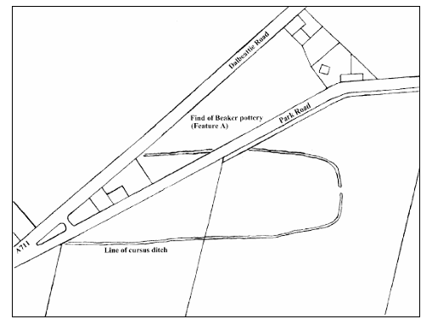
In 2002, a watching brief was undertaken during Scottish Water upgrading works to the Cargenbridge waste water pumping station and associated new sewers. The route of one of the new sewers ran along the south verge of Park Road, Maxwellton, Dumfries, crossing through both the northern and southern ditches of the cursus and a portion of its interior. The works revealed the northern ditch to be approximately 2.5 to 3m wide and 0.65m deep from the surface of the subsoil, while the southern ditch measured approximately 5m wide and 0.6m deep. The ditches appeared to have been truncated by the construction of the adjacent road, and their original dimensions would likely have been greater. Within the interior of the monument, the pipe trench revealed a semi-circular feature, which appeared to be the basal remains of a larger pit truncated during the construction of the road. The feature contained 20 sherds from a single vessel of ‘Beaker’ type dating from the late Neolithic to the Early Bronze Age (2600 to 1800 BC). A radiocarbon date of 3875 ± 45 BP was also obtained from the fill. Small fragments of burnt bone recovered from the feature suggested the possibility that it was the remains of a late Neolithic or Early Bronze Age cremation burial.

Methods: Aerial Photography; Monitoring
Period(s): Neolithic; Bronze Age
Dating: Radiocarbon (1)
Feature(s): Cremation (pos); Ditch; Pit
Material Culture: Pottery (Neolithic; Bronze Age)
Ecofacts: Charcoal (Quercus); Unidentified Bone (Burnt)
Last Update: August 2025 (CW)
Name: Derskelpin Farm, Glenluce
Location: NX 25299 592446
Local Authority: Dumfries and Galloway
NRHE: 310982
LA HER: MDG25337
HES: -
Museum: ?
Reference: Moore, Phil and Suddaby, Ian 2012 ‘A Burnt Mound and Wooden Posts on the A75 at Derskelpin Farm, Dergoals, Glenluce, 2010’, Trans Dum Gall Nat Hist Antiq Soc, 86, 37-50
Summary: A programme of archaeological fieldwork was undertaken in advance of construction work for a short stretch of dual carriageway on the A75 between Newton Stewart and Glenluce. The route comprised areas of improved pasture on drumlins and peat bog within the inter-drumlin basins. Some of the areas along the route were investigated by trial trenches and a burnt mound was discovered and later excavated. The burnt mound covered an area which measured 22m by 6m in extent but neither a hearth nor a trough was uncovered during the excavation. Although the heating of the stones took place outwith the excavated area, the remains appeared to represent a portion of the burnt mound. Its location at an interface between wet and dry land is common for such features and there was no evidence to suggest any importation of burnt mound material from further afield. Radiocarbon dating suggests that the burnt mound was probably formed in the later 1st millennium AD. Two main phases of activity were identified with the deposit of burnt stone being either preceded or succeeded by a series of posts, which might represent an early medieval fence line. Although it was not possible to determine which came first – the fence or the burnt mound – the radiocarbon dating suggests that they were broadly contemporary. A single flint flake was recovered. To the east, the burnt mound was overlain by a later clearance cairn from which an architectural fragment was recovered.
Methods: Evaluation; Excavation; Soil Micromorphology
Period(s): Early Medieval
Dating: Radiocarbon (6)
Feature(s): Burnt Mound; Postholes; Stakeholes
Material Culture: Lithic; Carved Stone Fragment; Structural Timbers
Ecofacts: Charcoal (Betula; Corylus; Quercus; Salix); Cereal (Avena; Hordeum); Nutshell (Corylus); Weed Seeds
Last Update: June 2024 (SC)
Name: Doonhill, Arran
Location: NR 89526 28432
Local Authority: North Ayrshire
NRHE: 348596
LA HER: 67429; 67430; 67431; 94102; 5504
HES: -
Museum: ?
Reference: Gordon, Douglas 2016 Doonhill Harbour View, Blackwaterfoot, Isle of Arran: Post-Excavation – Research and Analysis. Unpublished commercial report. Rathmell Archaeology Ltd
Summary: A programme of archaeological works was required by John Robertson and Sons Joiners Ltd in respect to the residential development and formation of an associated access road on land to the north of Doonhill Harbour View, Blackwaterfoot, Isle of Arran. An archaeological evaluation carried out in March 2015 identified previously unknown archaeological features leading to an excavation in June 2015. During the excavation, several groupings of pits were uncovered along with a semi-circular series of postholes. In addition, several hundred sherds of prehistoric pottery were recovered, including a sherd of carinated bowl, alongside 120 pieces of struck Arran pitchstone. The excavation at Doonhill revealed a Late Neolithic occupation site from the early to mid 3rd millennium BC. Central to this was a small post-built structure that was shielded from the immediate contemporary shore by two stretches of massive palisade fencing. Inland and upslope of this structure and screen were a series of pit arrays containing ‘Durrington Walls' style grooved ware pottery, burnt cereal grain and evidence for the manufacture of lithic tools from pitchstone. The consistent character of the archaeological strata across the site, and the evidence from the artefacts and ecofacts recovered, suggest a broadly contemporaneous site. The regularised form of pit formation, arrays and inclusions support this.
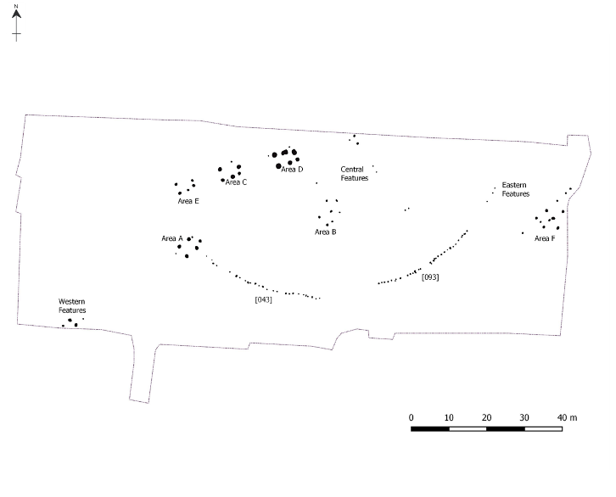

Methods: Evaluation; Excavation
Period(s): Neolithic; Bronze Age
Dating: Radiocarbon (6)
Feature(s): Lithic Working Site; Pits; Postholes; Palisade; Structure
Material Culture: Lithics (Neolithic; Bronze Age); Pottery (Neolithic)
Ecofacts: Cereal (Hordeum); Charcoal (Quercus; Betula; Alnus); Nutshell (Corylus)
Last Update: October 2024 (MM)
Name: Drummullan, Twynholm
Location: NX 65467 50172
Local Authority: Dumfries and Galloway
NRHE: 359120
LA HER: -
HES: -
Museum: ?
Reference: Wood, Alex 2020 ‘Snapshots into a Prehistoric Landscape: Early Neolithic and Iron Age Activity, Cluden to Brighouse Bay’, Trans Dum Gall Nat Hist Antiq Soc, 94, 33-49
Summary: A programme of archaeological monitoring work was undertaken by AOC archaeology Group on behalf of GNI (UK) Ltd during topsoil stripping operations for the 49.6km-long gas pipeline from Cluden to Brighouse Bay, Dumfries and Galloway. Two areas of features were identified at Drummullan (labelled RDX 50 in the publication). The features in the northern area produced little diagnostic evidence and could not be dated. The southern area consisted of a dense cluster of 14 pits. These were sub-oval in shape and ranged in size from 0.12 to 2.4m long, 0.1 to 2.5m wide and 0.05 to 0.7m deep. Pottery sherds from Early Neolithic carinated bowls were recovered from four of the pits. The lower fill of one of these pits produced two radiocarbon dates of 3640-3522 BC and 3517-3368 BC. The pits might represent short-term and transient use of the site (for example, for seasonal cooking events). However, the author states that there is an ongoing debate about whether pit clusters could be indicators of settlement and permanence.
Methods: Monitoring; Excavation
Period(s): Neolithic
Dating: Radiocarbon (2)
Feature(s): Pits
Material Culture: Industrial Debris; Pottery (Neolithic)
Ecofacts: Cereal (Triticum); Charcoal (Alnus; Corylus; Sorbus; Quercus); Nutshell (Corylus)
Last Update: September 2024 (CW)
Name: Dunrod, Kirkcudbright
Location: NX 69972 45905
Local Authority: Dumfries and Galloway
NRHE: 63927
LA HER: MDG3522
HES: SM2343
Museum: Dumfries Museum
Reference: Davies, E F Burdon 1966 ‘The Moated Manor at Dunrod, Kirkcudbright’, Trans Dum Gall Nat Hist Antiq Soc, 43, 121-36
Summary: The homestead at Dunrod consists of a rectangular platform measuring 120ft (36.5m) north/south by 110ft (33.5m) transversely surrounded by a 20ft (6.1m) wide moat. The surface of the platform shows traces of a building in the northeast quarter and there is a spillway at the southwest corner. Excavations were carried out in 1964 and 1965 when a trench was opened running east/west parallel to the southern inner rampart, cutting across the moat on the west at a right angle and also across the inner and outer ramparts. The pottery found was mainly 13th century in date, placing the construction of the moated platform in this century and also indicating a period of occupation of less than 100 years. A few fragments of 15th or 16th-century pottery were also found, suggesting a possible re-occupation of the site with improvements made at that time to control the level of the water in the moat. At an unknown date, the moat was destroyed and filled with worked stone from the platform’s retaining walls and from the wall on its shore with the outer rampart. Animal bone, leather, a lead spindle whorl and two flint flakes were also recovered.
Methods: Excavation
Period(s): Medieval
Dating: -
Feature(s): Moat; Ramparts
Material Culture: Pottery (Medieval); Metal Artefact (Medieval); Lithics
Ecofacts: Animal Bone; Unidentified Bone (Burnt); Leather
Last Update: August 2024 (MM)
Name: Evan Road, Beattock
Location: NT 08112 02246
Local Authority: Dumfries and Galloway
NRHE: 48406
LA HER: MDG317
HES: -
Museum: ?
Reference: Dunbar, Lindsay J 2008 ‘An Enclosure and other features at Evan Road, Beattock, Dumfries & Galloway’, Trans Dum Gall Nat Hist Antiq Soc, 82, 41-8
Summary: A ditch formed trapezoidal enclosure of sides 23m to 28m identified from aerial photographs was partly excavated. The ditch had a V-shaped profile 1.3m to 0.5m wide and 0.3m to 0.4m deep cut into fluvio-glacial gravels. Entrance to north with additional ditch sections. Enclosure inferred Iron Age for animal husbandry based on its form. Residual Neolithic (1) and later Modern (2) radiocarbon dates from charcoal in ditch fill. Five pits within the enclosure, Pit 2 which measured 0.81m by 0.62m in plan and was 0.2m deep contained fire-cracked stones and was interpreted as a cooking hearth with Mesolithic radiocarbon dates (2) from charcoal. Two parallel linear arrays of postholes to north of the enclosure; further north curvilinear ditch and three intercutting pits. Also a post-medieval well.
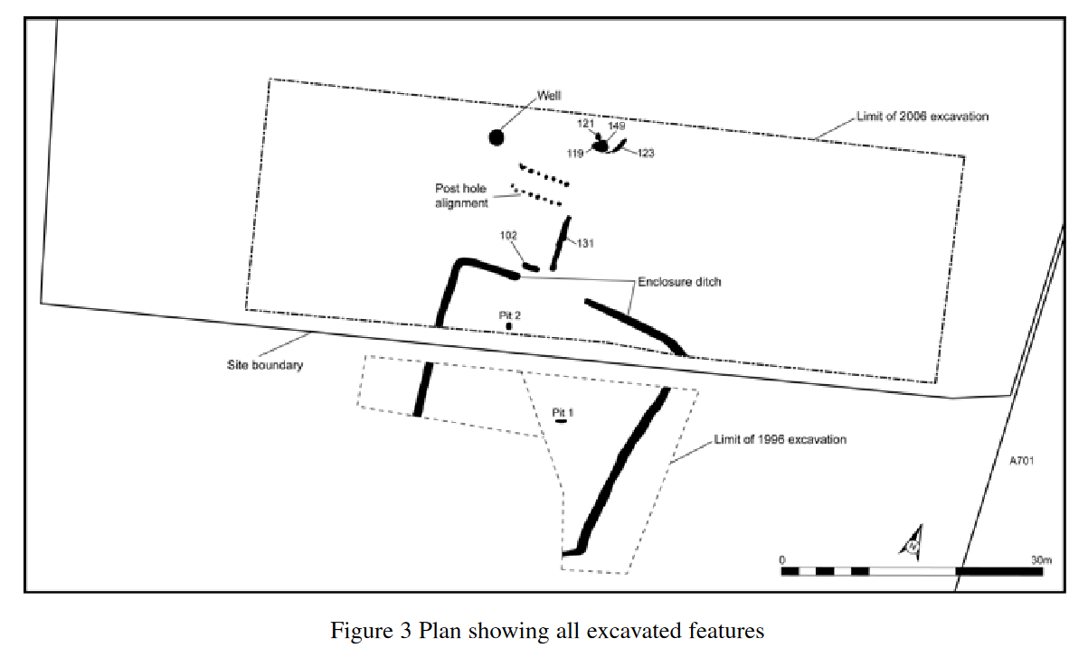
Methods: Aerial Photography; Evaluation; Excavation
Period(s) : Mesolithic; Neolithic; Iron Age; Post-Medieval; Modern
Dating: Radiocarbon (5)
Feature(s): Ditch; Enclosure; Pit; Hearth; Posthole; Well
Material Culture: Clay Tobacco Pipe; Glass; Industrial Residue; Pottery (Post-Medieval; Modern)
Ecofacts: Charcoal (Quercus; Corylus; Alnus; Fraxinus; Calluna)
Last Update: June 2024 (TR)

Name: Garden Street, Newton-upon-Ayr
Location: NS 33885 22248
Local Authority: South Ayrshire
NRHE: 41752
LA HER: 381
HES: -
Museum: ?
Reference: Perry, David and Mackenzie, James 2012a ‘Garden Street 1C’ in Perry, David Excavations in Ayr 1984-1987: 37-38. Ayr Archaeol Nat Hist Soc Monograph 37: Ayr
Perry, David and Mackenzie, James 2012b ‘Garden Street 1CA-1CC’ in Perry, David Excavations in Ayr 1984-1987: 37-38. Ayr Archaeol Nat Hist Soc Monograph 37: Ayr
Summary: An excavation was conducted in June and July 1984 in an area 15m east of Garden Street and 4m south of the modern Cross Street. Evidence of cultivation activity, possibly dating to the 14th and 15th centuries, represented the earliest phase on site. Possible evidence of a structure was also revealed, though too little was exposed to be certain. In the 16th and 17th centuries, the area seems to have been part of the grounds of Newton Castle with dumps of domestic ash and cinders layered with domestic rubbish potentially created by the manuring of cultivation soil with domestic rubbish. In the subsequent centuries of the 18th and early 19th centuries, the area was consistently used as a dump; this presumably ceased when the ground was laid out as formal gardens in the early to mid 19th century.
A subsequent excavation was carried out in Garden Street between July to December 1984. It was located 14m southwest of the first excavation and closer to the modern street frontage on ground dropping down to River Street. Five phases of occupation were identified. The earliest activity was represented by cultivation slots, possibly of the late 14th century, which predated a path, timber structure and possible boundary dated to the 14th and 15th centuries by pottery finds. The timber structure was potentially of stake-and-wattle construction with at least one internal division. A possible enclosed yard area to the west is represented by a fence slot and a stake line, which may have served to hold animals back from the walls. After the buildings had gone out of use in the 15th or 16th century, no further buildings were constructed until the 19th century. The property divisions were not maintained and, in the 17th and 18th centuries, the ground appears to have been open ground with a stone sump for drainage. The final phase of activity was in the 19th and 20th centuries, which saw this area of the burgh of Newton built on after a long period as open ground.
Methods: Excavation
Period(s): Medieval; Post-Medieval; Modern
Dating: -
Feature(s): Cultivation; Postholes; Stakeholes; Structures
Material Culture: Bone Artefact (Modern); CBM; Coarse Stone Artefact (Medieval); Coins (Post-Medieval; Modern); Metal Artefacts (Medieval); Pottery (Medieval; Post-Medieval; Modern)
Ecofacts: Animal Bone
Last Update: January 2025 (LA)
Name: Girvan Mains Roman Camps
Location: NX 18884 99078
Local Authority: South Ayrshire
NRHE: 62049; 71541
LA HER: 11408; 12036
HES SM5596
Museum ?
Reference Frere, Sheppard S 1991 ‘Roman Britain in 1990: I. Sites Explored’, Britannia, 22, 222-292
Jones, Rebecca H 2011 Roman Camps in Scotland, Soc Antiq Scot: Edinburgh
Maxwell, Gordon S and Wilson, David R 1987 ‘Air Reconnaissance in Roman Britain 1977-84’, Britannia, 18, 1-48
St Joseph, John K 1978 ‘A Roman Camp near Girvan, Ayrshire’, Britannia, 9, 397-400
Summary On the north bank of the Water of Girvan, overlooking the North Channel, lie two intersecting camps recorded in the 1970s as cropmarks by Cambridge University. The eastern of the two measures about 560m from west to east by 390m transversely and encloses 22ha (54.5 acres). Two trenches were excavated across the line of the cropmark by St Joseph in 1977. They both revealed a V-shaped ditch measuring 3.05m wide and 1.25m deep, which had evidently gradually silted up. St Joseph reported that he had recovered the northwest corner of the camp. However, later aerial photography in 1989, reported by Frere, showed the western edge of the camp to sit 100m further to the west than previously thought. The western camp intersects the eastern example at its southwest corner and measures 353m from southwest to northeast by at least 140m; the position of the northwest side is unknown. Excavations in the 1980s, reported by Maxwell and Wilson, established that the ditch was V-shaped, not more than 1.37m wide and 1.06m deep, with a squared slot or channel at the bottom in some sections. A fragment of a glass vessel dating to the late 1st century AD was recovered from the primary ditch fill in one of the sections, indicating that the camps may have been part of the Agricolan military campaign in Scotland.
Methods Aerial Photography; Excavation
Period(s) Roman
Dating -
Feature(s) Ditch
Material Culture Glass (Roman)
Ecofacts -
Last Update April 2025 (CW)
Name: Halfway House, Kirkcowan
Location: NX 30570 61749
Local Authority: Dumfries and Galloway
NRHE: 62983
LA HER: MDG5
HES: -
Museum: ?
Reference: Owen, Olwyn 1991 ‘The Excavation of a Post-Medieval Building at Halfway House, by Kirkcowan, Wigtownshire, Dumfries and Galloway’, Trans Dum Gall Nat Hist Antiq Soc, 66, 67-78
Summary: Excavation of a site, necessitated by the realignment of the A75 Dumfries to Stranraer road, revealed the foundations of a post-medieval house. The site was interpreted on ground surface indications as a pre-Clearance, perhaps medieval, farmstead (the rectangular building) overlying an earlier, possibly prehistoric site (represented by the crescentic bank). This hypothesis was tested by excavation which uncovered three phases of landuse in the area: firstly, early landuse was identified by changed subsoil with burnt material, secondly, a rectangular building forming a post-medieval house and lastly, an overlying cresentic bank. The rectangular building measured 9.2 by 3.2m internally, giving an internal area of some 29.5 square metres, and does not appear to have been partitioned. The building overlay earlier features identified by a spread of dark brown clay containing burnt material. Interpretation of the building is most argued as a post-medieval farmstead but this could not be positively confirmed through coring or field systems due to rocky outcrops. Other proposed interpretations include a staging post between Newton Stewart and Glen Luce.
Methods: Excavation
Period(s): Medieval; Post-Medieval
Dating: -
Feature(s): Building; Hearth; Bank
Material Culture: Glass (Post-Medieval; Modern); Metal Artefacts (Medieval; Post-Medieval; Modern); Pottery (Medieval; Modern); Clay Tobacco Pipe; Bone Artefact; Coarse Stone Artefacts
Ecofacts: Animal Bone
Last Update: June 2024 (SC)
Name: Hallmeadow Place, Annan
Location: NY 19166 65798
Local Authority: Dumfries and Galloway
NRHE: 363466
LA HER: MDG27323
HES: -
Museum: ?
Reference: Green, Kenneth 2022 ‘Burnt Mounds at Annan’, Trans Dum Gall Nat Hist Antiq Soc, 96, 41-60
Summary: Development works at Hallmeadow Place, Annan by Cunninghame Housing Association led to an initial archaeological metal detecting survey and evaluation being carried out across the site by GUARD Archaeology in 2018. A second phase followed in 2020 which included a monitored topsoil strip and watching brief. Two previously unknown burnt mounds were uncovered during this work, which were situated towards the southern boundary of the site. The excavation of the burnt mounds revealed features that were typical of this type of monument such as centrally positioned pits surrounded by deposits of burnt stones. The position of a possible trough was found in the eastern burnt mound along with evidence of a peripheral channel or channels surrounding the location. A number of stratigraphic layers were exposed which suggest that the burnt mounds were reused a number of times. Radiocarbon dating of samples from the analysis of the carbonised plant macrofossils and charcoal revealed early activity in the area from the late Mesolithic through to the later Neolithic period. However, the burnt mounds were dated to the early Bronze Age: with the eastern burnt mound probably in use earlier and longer than the western burnt mound. Very little artefactual evidence was associated with either structure apart from a few burnt flint fragments, which again indicate earlier prehistoric activity in the area.
Methods: Metal Detecting Survey; Evaluation; Monitoring; Excavation
Period(s): Bronze Age
Dating: Radiocarbon (10)
Feature(s): Burnt Mounds; Pits; Hearths; Gullies
Material Culture: Glass (Modern); Lithics (Neolithic); Quartz
Ecofacts: Charcoal (Alnus; Betula; Corylus; Quercus); Cereal (Hordeum; Triticum); Nutshell (Corylus)
Last Update: August 2024 (LA)
Name: Hayknowes Enclosures, Annan
Location: NY 17457 65608
Local Authority: Dumfries and Galloway
NRHE: 66473
LA HER: MDG6848
HES: SM12092
Museum: ?
Reference: Gregory, Richard A 2001a ‘Excavation at Hayknowes Farm, Annan’, Trans Dum Gall Nat Hist Antiq Soc, 75, 29-46
Summary: Research conducted at Hayknowes Farm involved the geophysical survey and excavation of elements of extensive cropmarks previously identified through aerial photography. Samples of two enclosures were excavated: an oval double-ditched enclosure and a rectilinear enclosure. Excavation of the double-ditched enclosure investigated an entrance in the northwest, revealing the presence of an internal gate and possible palisade. A ring-groove roundhouse sitting within the interior of the enclosure was also excavated revealing novel features including an internal square timber frame for the roof and opposing entrances to the northwest and southeast. Excavation of the rectilinear enclosure investigated an entrance in the east, revealing an internal gate, and an area of the interior, although no features were uncovered in the latter. Radiocarbon dates place both enclosures within different phases of the Iron Age; the features indicate a process of accretion with certain elements falling into disuse as others were constructed over a considerable period. It appears that in this locale, at least, a thriving Late Iron Age ‘centre’ became established, with the evidence suggesting that the control of agricultural resources and livestock may well have been integral to its success.
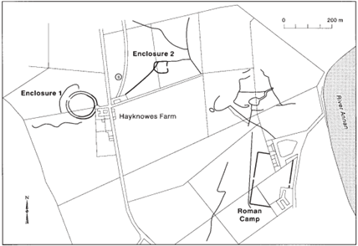

Methods: Aerial Photography; Excavation; Geophysical Survey
Period(s): Iron Age
Dating: Radiocarbon (4)
Feature(s): Cropmarks; Ditch; Gully; Hearth; Palisade; Postholes; Stakeholes; Roundhouse; Rock Art; Enclosure; Post-Pad; Rampart
Material Culture: Carnelian Artefact; Coarse Stone Artefacts; Pottery (Medieval)
Ecofacts: Animal Bone; Animal Bone (Burnt); Charcoal (Quercus; Prunus)
Last Update: June 2024 (LA)
Name: Hayknowes Ring Ditch, Annan
Location: NY 17401 65718
Local Authority: Dumfries and Galloway
NRHE: 66451
LA HER: MDG6829
HES: -
Museum: ?
Reference: Gregory, Richard A 2001b ‘The excavation of a medieval ring-ditch enclosure at Hayknowes Farm, Annan, Dumfries and Galloway’, Scot Archaeol J, 23.2, 119-139
Summary: Excavation at a cropmark site found close to Annan, Dumfries and Galloway, revealed evidence of a ring ditch measuring around 25m in diameter containing a number of intriguing internal structures. Initially this was presumed to be a prehistoric monument, but pottery and radiocarbon dating, unexpectedly, indicated that the main structural phase of the site falls between the 11th and 13th centuries AD. This suggests that a degree of caution is required when interpreting cropmark sites on morphological characteristics alone. The site was determined to have two phases. The initial use of the site is represented by a possible oven or hearth from the period 240 to 600 AD, which predated the construction of the ring ditch. A longer more defined phase then occurred between the 11th and 13th centuries when the ring ditch was created. The ring ditch likely had an internal bank but there was no evidence of a break in the ditch to indicate the site of an entrance; it is possible that access was by an ephemeral bridge, which may have been no more than a few planks laid over the enclosing ditch. At its centre were four large pits, potentially enclosed within a timber building. It is possible that the pits were used for grain storage and that the site functioned as a fortified agricultural store. Finds from the site include medieval pottery and a fragment of a lignite bracelet. The excavation makes clear that morphological interpretation can have a constraining influence on excavation strategy, so caution is required when designing fieldwork programmes.
Methods: Aerial Photography; Excavation; Geophysical Survey
Period(s): Iron Age; Early Medieval; Medieval
Dating: Radiocarbon (3)
Feature(s): Cropmark; Ring Ditch; Ditch; Bank; Pits; Postholes; Stakeholes; Building
Material Culture: Pottery (Medieval); Lignite Artefact
Ecofacts: Charcoal (Quercus); Cereal (Hordeum); Weed Seeds
Last Update: August 2024 (LA)

Name: High Milton Dun, Craigoch
Location: NX 01210 66820
Local Authority: Dumfries and Galloway
NRHE: 60744
LA HER: MDG904
HES: SM4814
Museum: ?
Reference: Cavers, Graeme and Humble, Jamie 2020 ‘Excavations at an Iron Age Dun at High Milton, Craigoch, Rhins of Galloway’, Trans Dum Gall Nat Hist Antiq Soc, 94, 51-65
Summary: AOC Archaeology Group were commissioned by Historic Environment Scotland to undertake an evaluation excavation at High Milton Dun, Craigoch, Dumfries and Galloway. The excavations aimed to assess the survival of archaeological structures and deposits following damage caused by stone quarrying at the site. The excavations identified a bank at the knoll's crest, enclosing a circular structure with a suggested internal diameter of around 8.8m. Within the circular structure was an area of rough paving and associated occupation deposit. Rubble collapse deposits overlay these structures. The results indicated that, while badly damaged, at least one internal domestic structure survived, perhaps as much as 50% of the original building, along with occupation deposits relating to Iron Age activity, probably in the early decades of the first century AD. While limited in extent, these excavations provided the first reliable dating evidence for the class of small stone forts – variously referred to as ‘homesteads’ or ‘duns’ – in Galloway.
Methods: Excavation
Period(s): Iron Age
Dating: Radiocarbon (2)
Feature(s): Bank; Structure; Wall
Material Culture: Metal Artefact; Pottery (Post-Medieval)
Ecofacts: Animal Bone; Cereal (Avena; Hordeum; Triticum); Charcoal (Alnus; Calluna; Corylus); Fungal Spores; Weed Seeds
Last Update: September 2024 (MM)

Name: High Torrs, Luce Bay
Location: NX 14100 55600
Local Authority: Dumfries and Galloway
NRHE: 61221
LA HER: MDG1282
HES: -
Museum: ?
Reference: Breeze, David J and Ritchie, J N Graham 1980 ‘A Roman Burial at High Torrs, Luce Sands, Wigtownshire’, Trans Dum Gall Nat Hist Antiq Soc, 55, 77-85
Mann, Ludovic M 1933 ‘Some Recent Discoveries’, Presidential Address 19 March 1931, Trans Glasgow Archaeol Soc, 8 (1927-33), 138-151
Summary: In 1931, Ludovic Mann undertook the rescue excavation of a small cairn at High Torrs, Wigtownshire. A large number of rough undressed boulders formed the cairn which sat some 200m west of a grassy mound in the dunes known as Horse Hill. The stones were removed to reveal the presence of a cremated burial accompanied by fragments of two samian vessels of later 2nd or early 3rd century date, a finger-ring with a nicolo intaglio and a number of iron objects. Mann interpretated the iron objects as weapons, concluding that the burial was that of a Roman warrior. It is thought that the body was cremated on the spot, with the cremated remains then gathered together and buried before being covered by the boulders. Re-examination of the material by Breeze and Ritchie suggested that the ironwork did not include any weapons, however, and the military nature of the burial was thus lessened. They explain that, prior to their work, the finds had not been examined for 40 years and misconceptions about their identifications had persisted, particularly as no detailed finds catalogue had previously been prepared. The finds and the use of cremation, a Roman burial practice, indicate the burial is that of a Roman traveller and not a Romanized native. The deceased is perhaps most likely to have been a sailor or soldier, as Mann suggested, or a merchant, possibly a smith.
Methods: Excavation
Period(s): Roman
Dating: -
Feature(s): Cairn; Cremation
Material Culture: Metal Artefacts (Roman); Industrial Residue; Pottery (Roman)
Ecofacts: Human Bone (Burnt); Charcoal (Alnus; Betula; Quercus; Salix; Ulmus)
Last Update: June 2024 (LA)
Name: Hillhouse Farm, Kilmarnock
Location: NS 45715 40173
Local Authority: East Ayrshire
NRHE: -
LA HER: 5996; 69875; 6880
HES: -
Museum: ?
Reference: Green, Kenny, Alldritt, Diane, Ballin, Torbin and Sheridan, Alison 2021 ARO44: Exceptional pots: the early Neolithic of Hillhouse Farm, Kilmarnock, East Ayrshire, Archaeology Reports Online
Summary: Between 26 April and 14 August 2017 an archaeological watching brief was undertaken by GUARD Archaeology following the Highlees water pipeline route on behalf of Scottish Water. The pipeline started northeast of Kilmarnock at the Water Treatment Works at Amlaird, extended south and west passing Kilmarnock to the southeast, to terminate at the Highlees Water Treatment Works near Dundonald. During the works, several Neolithic features were excavated at Hillhouse Farm (labelled Area 3 in the publication). These consisted of a number of groups of pits and postholes, some of which are dated to the 37th to 34th centuries BC. A few small fragments of burnt flint were recovered from some of the features along with 218 fragments of early Neolithic pottery representing between 19 and 23 pots. Many of the features also contained quantities of charcoal, particularly from oak and hazel with some fragments of alder, and numerous fragments of hazel nutshell. The evidence represents some of the materials used in the construction of the building as well as fuel and wild resources available to its inhabitants.
Methods: Excavation
Period(s): Neolithic
Dating: Radiocarbon (4)
Feature(s): Pits; Postholes
Material Culture: Lithics; Pottery (Neolithic)
Ecofacts: Charcoal (Quercus; Corylus; Alnus); Nutshell (Corylus)
Last Update: October 2024 (MM)

Name: Hilltop, Twynholm
Location: NX 67810 54230
Local Authority: Dumfries and Galloway
NRHE: 359120
LA HER: -
HES: -
Museum: ?
Reference: Wood, Alex 2020 ‘Snapshots into a Prehistoric Landscape: Early Neolithic and Iron Age Activity, Cluden to Brighouse Bay’, Trans Dum Gall Nat Hist Antiq Soc, 94, 33-49
Summary: A programme of archaeological monitoring work was undertaken by AOC Archaeology Group on behalf of GNI (UK) Ltd during topsoil stripping operations for the 49.6km-long gas pipeline from Cluden to Brighouse Bay, Dumfries and Galloway. Three distinct areas of pit features were identified within a 300m stretch of the pipeline to the west of Hilltop in Twynholm (labelled RDX 46 in the publication). The northernmost area was subsequently excavated. It consisted of a cluster of ten pits measuring between 0.46 and 1.23m long, 0.35 and 1.13m wide, and 0.05 and 0.25m deep. Pottery sherds from Early Neolithic carinated bowls were recovered from four of the pits. Two corresponding radiocarbon dates of 3638-3518 BC and 3641-3522 BC were obtained from the fill of one of these pits. The pits might represent short-term and transient use of the site (for example, for seasonal cooking events). However, there is an ongoing debate about whether pit clusters could be indicators of settlement and permanence.
Methods: Monitoring; Excavation
Period(s): Neolithic
Dating: Radiocarbon (2)
Feature(s): Pits
Material Culture: Pottery (Neolithic)
Ecofacts: Charcoal (Alnus; Corylus; Sorbus; Quercus); Nutshell (Corylus)
Last Update: August 2024 (CW)

Name: Holywood North
Location: NX 95020 80120
Local Authority: Dumfries and Galloway
NRHE: 65851
LA HER: MDG6308
HES: SM4217
Museum: ?
Reference: Thomas, Julian 2007b ‘The Holywood cursus complex, excavations’ in Thomas, Julian (ed) Place and Memory: Excavations at the Pict’s Knowe, Holywood and Holm Farm, Dumfries and Galloway, 1994-8: 166-199. Oxbow Books: Oxford
Summary: Holywood North is the northern example of two Neolithic cursus monuments located to the northwest of Dumfries. Identified through aerial photography, the cursus monument is aligned south-southwest/north-northeast and is defined by a broad ditch with rounded terminals. It measures some 400m long by 30m wide. For much of its north half, the ditch is flanked internally by a line of postholes and pits visible on aerial photography. Two opposing breaks in the ditch along the sides of the cursus mark the only visible entrances, which sit about 130m from the northern terminal. The monument was excavated in 1997 as a collaboration between Historic Scotland and the University of Southampton to test the preservation of the monument in the face of long-term animal and agricultural damage. Two trenches were opened: one over the northern terminal and the second positioned across the entrance in its southeast side. The cursus ditch was sectioned in six places and measured between 1.2 and 1.45m deep. In each case the basic sequence was one of a brief silting from the edge of the ditch, followed by an infill of gravel, presumably from an internal bank, and above this a fine silting, which appears to have accumulated in a small recut in the top of the ditch. Numerous cut features lay within the circuit of the cursus ditch, most of these representing large postholes. In some cases, the remains of burnt posts remained, while others showed evidence of having been pulled out.
It was initially argued that the posts were integral to an internal bank and that their firing coincided with a deliberate backfilling of the ditch. However, more recent analysis has shown that the posts were renewed or replaced on a number of occasions and it is unlikely that they were contemporary with the ditch. Instead, it is possible that these features represent an earlier post-defined cursus, potentially first constructed around 3890 to 3650 cal BC (from radiocarbon dating), which went through varying phases of construction. A later date of 3640 to 3490 cal BC from one of the postholes might suggest the end of the timber phase although this may have come from reused material. The earlier timber structure was later enclosed by the ditch, with the internal bank sealing any remaining traces of the timber architecture. One interpretation given is that this act transformed the site from an accessible structure used for performance into a place of memory and veneration. The later ‘ditch-and-bank’ monument appears to have stood for a comparatively short period of time before the bank was levelled, either through collapse or deliberate backfilling, and infilled the ditch. Use of the site continued after this, however. A post façade across the eastern entrance may post-date the slighting of the bank and may or may not have been contemporary with the recutting of the ditch. A radiocarbon date places the recutting of the ditch as around 2310 to 2120 cal BC. A ring ditch was placed in direct association with the entrance, potentially positioned so as to dominate the point of access into the monument or the route by which it was crossed. The ring ditch did not produce any material culture but may have also been constructed in the Early Bronze Age.
Methods: Aerial Photography; Excavation; Phosphate Analysis
Period(s): Neolithic; Bronze Age
Dating: Radiocarbon (6)
Feature(s): Bank (pos); Ditch; Pits; Postholes; Ring Ditch
Material Culture: Lithics (Mesolithic; Neolithic); Pottery (Neolithic)
Ecofacts: Cereal (Triticum); Charcoal (Betula; Corylus; Pinus; Quercus); Nutshell (Corylus); Weed Seeds
Last Update: April 2025 (CW)
Name: Holywood South
Location: NX 94890 79660
Local Authority: Dumfries and Galloway
NRHE: 65652
LA HER: MDG6107
HES: SM4218
Museum: ?
Reference: Thomas, Julian 2007b ‘The Holywood cursus complex, excavations’ in Thomas, Julian (ed) Place and Memory: Excavations at the Pict’s Knowe, Holywood and Holm Farm, Dumfries and Galloway, 1994-8: 166-199. Oxbow Books: Oxford
Summary: Holywood South is the southern example of two Neolithic cursus monuments located to the northwest of Dumfries. Identified through aerial photography, the cursus monument is aligned south-southeast/north-northwest and is defined by a broad ditch with square terminals. It measures some 300m long by 40m wide at its southern end, narrowing to 30m wide to the north. The ditch is broken at several points and there are several internal and associated features visible on the aerial photographs. Within its northern end, a ring ditch, roughly 11m in diameter, and two pit-like features are visible. Towards the south end there is a semi-circular ditched area containing two pit-like features and a rectangular enclosure. The monument was excavated in 1997 as a collaboration between Historic Scotland and the University of Southampton to test the preservation of the monument in the face of long-term animal and agricultural damage. A single trench was opened over the northern terminal of the cursus which encompassed a gap in the cursus ditch, the ring ditch and a sample of other internal features. Two sections were cut through the cursus ditch revealing a broad U-shaped profile measuring up to 1.2m deep. The fills of the ditch suggested that there had been a dump bank which started to erode quite quickly back into the ditch. Such a bank must have covered a group of pits enclosed within the terminal of the cursus, which presumably pre-dated the monument. These contained complex fillings, much burnt material and earlier Neolithic pottery. Traditional interpretation suggests that the ring ditch is a later addition, adding to the significance of the entrance or exit, but it produced no dating evidence and its position in the phasing remains uncertain.
Methods: Aerial Photography; Excavation; Phosphate Analysis
Period(s): Neolithic
Dating: -
Feature(s): Bank (pos); Ditch; Pits; Postholes; Ring Ditch; Stakeholes
Material Culture: Pottery (Neolithic); Quartz
Ecofacts: Charcoal (Corylus; Quercus); Nutshell (Corylus)
Last Update: April 2025 (CW)
Name: Irish Street, Dumfries
Location: NX 97170 75950
Local Authority: Dumfries and Galloway
NRHE: -
LA HER: MDG5131
HES: -
Museum: ?
Reference: Mackenzie, J R 2002 ‘A Multi-Period Site at 67-71 Irish Street, Dumfries, the former British Legion Club-House’, Trans Dum Gall Nat Hist Antiq Soc, 56, 119-140
Summary: An excavation in advance of redevelopment at the British Legion Club on Irish Street produced evidence of prehistoric activity. On riverine and raised beach deposits a Mesolithic lithic scatter and rectangular pit, the latter containing two postholes and stakeholes and interpreted as a windbreak or drying rack, was identified. The lithics (60) were a narrow blade assemblage using chert, flint and jasper with a core and microliths (2). Three small patches of spatially distinct of charcoal were dated to the late Neolithic (radiocarbon date). These remains were sealed by a homogenous medieval ‘garden soil’ some 0.6m thick which was in turn cut by a post-medieval drain and well. These later features were sealed by a second ‘garden soil’ and modern overburden.
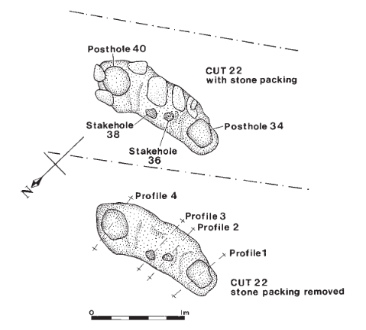
Methods: Excavation
Period(s): Mesolithic; Neolithic; Medieval; Post-Medieval
Dating: Radiocarbon (1)
Feature(s): Pit; Posthole; Stakehole; Drain; Well
Material Culture: Lithics (Mesolithic); Pottery (Medieval; Post-Medieval); Clay Tobacco Pipe; Roofing Slate (Modern); CBM (Post-Medieval)
Ecofacts: Nutshell (Corylus); Charcoal (Uniden; Quercus)
Last Update: June 2024 (TR)

Name: Kerricks Farm, Duncow
Location: NX 95997 83740
Local Authority: Dumfries and Galloway
NRHE: 268293
LA HER: MDG21385; MDG6313
HES: -
Museum: ?
Reference: Parry, Jim 2005 ‘Excavations of a Bronze Age Barrow at Kerricks Farm near Duncow’, Trans Dum Gall Nat Hist Antiq Soc, 79, 71-89
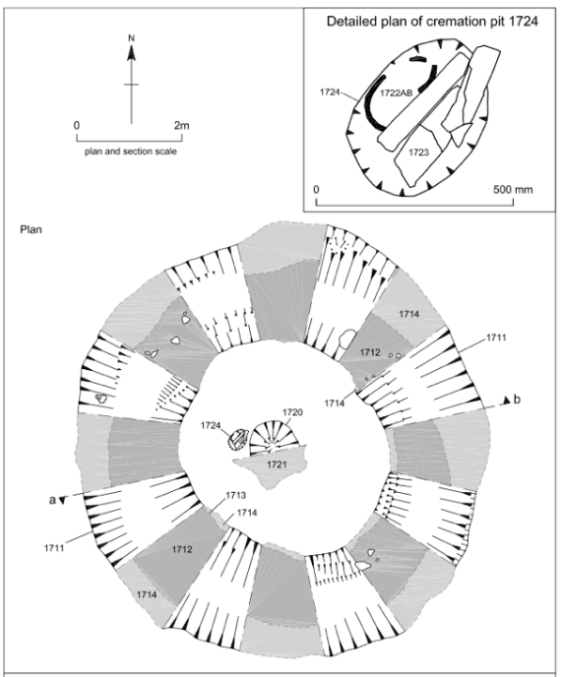
Summary: Between April and July 2002 an archaeological watching brief was carried out during groundworks for the construction corridor of the Scotland to Ireland Second Gas Interconnector Project land pipeline between Beattock and Cluden in Dumfries and Galloway. During topsoil stripping across a floodplain to the east of the River Nith, the partial remains of a barrow were identified. The barrow comprised a ring ditch with an external diameter of some 8m and an internal diameter of nearly 4m. The ditch showed two phases of activity: radiocarbon dates indicated that the initial construction of the barrow dated to between 2140 and 1880 cal BC, and that it was re-cut between 210 cal BC and AD 10 after a period of relative abandonment of the monument. The ditch surrounded two central cremation pits, one containing the remains of a scattered cremation and the other, an almost complete ‘bucket urn’ with its contents intact. Both sets of cremations consisted of two individuals (in both cases probably an adult female and an infant or juvenile) and have been radiocarbon-dated to the middle to late Bronze Age, between 1430 and 850 cal BC. The barrow is probably associated with a wider group of linear features observed as crop marks to the east of the pipeline corridor.

Methods: Excavation
Period(s): Bronze Age; Iron Age
Dating: Radiocarbon (4)
Feature(s): Cremation; Ring Ditch; Barrow
Material Culture: Pottery (Bronze Age); Lithic; Coarse Stone Artefact (Bronze Age)
Ecofacts: Charcoal; Human Bone (Burnt)
Last Update: August 2024 (MM)
Name: Littlehill Bridge, Girvan
Location: NS 19300 00280
Local Authority: South Ayrshire
NRHE: 89826
LA HER: 996; 15862
HES: -
Museum: ?
Reference: MacGregor, Gavin and Donnelly, Michael 2001 ‘A Mesolithic Scatter from Littlehill Bridge, Girvan, Ayrshire’, Scot Archaeol J, 23.1, 1-14
Summary: As part of a programme to build a new sewage treatment plant north of Girvan, near Girvan Mains Farm, an access road was constructed from the A77 to the plant. A watching brief was carried out to monitor the topsoil stripping associated with the road construction in 1994. Discovery of worked flint during these operations led to a brief investigation of the exposed surface to characterise the archaeological deposits. An assemblage of 366 lithics was recovered from deposits which appear to represent a scooped occupation. Analysis of the assemblage and a radiocarbon date range of 6355–6012 cal BC indicated that the site is Mesolithic. The site is significant because it produced the first Mesolithic material recovered by excavation in the Girvan area. It also provides additional evidence for a class of semi-permanent Mesolithic sites consisting of shallow scoops surrounded by turf or earthen banks.
Methods: Watching Brief; Excavation
Period(s): Mesolithic
Dating: Radiocarbon (1)
Feature(s): Lithic Working Site
Material Culture: Lithics (Mesolithic)
Ecofacts: Charcoal (Corylus)
Last Update: October 2024 (MM)
Name: Lochhill
Location: NX 96880 65070
Local Authority: Dumfries and Galloway
NRHE: 65428
LA HER: MDG5888
HES: -
Museum: ?
Reference: Masters, Lionel 1973 ‘The Lochhill long cairn’, Antiquity, 47, 96-100
Sheridan, Alison 2023 Lochhill and Slewcairn: completing two important projects by the late Lionel Masters. Unpublished interim report
Summary: An excavation at Lochhill, Kirkcudbrightshire was run from 1969 to 1971 by Lionel Masters. It revealed an interesting trapezoidal cairn with a shallow megalithic facade. The cairn, facade and (probably at least part of) the ‘stone’ chamber had been added to an earlier funerary monument, which began as a free-standing, open-sided timber mortuary chamber fronted by a timber facade. Masters theorised that the long cairn belonged within the Clyde group of chambered cairns, although it possessed a somewhat peculiar chamber, with the stone cairn built after the mortuary structure and timber façade had been deliberately burned down, suggesting two periods of construction. A single incomplete cremation was identified within the cairn, potentially indicating that they were an important person to the surrounding community. It is uncertain if the cremation was placed as a token deposit after the mortuary structure burnt down or if they were present in the mortuary structure, as disarticulated body parts, and became cremated as it was burnt down. The final blocking up of the stone forecourt façade is likely to have taken place during the Chalcolithic or Early Bronze Age, when a Beaker pot was deposited on top of the cairn. Radiocarbon dating provided consistent dating with 3708-3527 cal BC recorded. Over 180 sherds of Early Neolithic pottery of the Carinated Bowl tradition were recorded, representing eight or nine vessels which may have been deposited with offerings to the dead during the timber mortuary structure’s use. An Anglo-Saxon silver coin was identified during the excavation and is theorized to be a possible casual loss or a good luck deposit.
Methods: Excavation
Period(s): Neolithic; Bronze Age
Dating: Radiocarbon (4)
Feature(s): Long Cairn; Pit; Posthole
Material Culture: Pottery (Neolithic; Bronze Age); Lithics (Mesolithic; Neolithic); Coin (Early Medieval)
Ecofacts: Human Bone (Burnt); Charcoal (Betula, Quercus)
Last Update: December 2024 (LA)
Name: Lockerbie Academy
Location: NY 13361 82715
Local Authority: Dumfries and Galloway
NRHE: 281336
LA HER: MDG21895
HES: -
Museum: ?
Reference: Kirby, Magnus 2011 Lockerbie Academy: Neolithic and Early Historic timber halls, a Bronze Age cemetery, an undated enclosure and a post-medieval corn-drying kiln in south-west Scotland, Scottish Archaeological Internet Reports 46
Summary: Trial trenching carried out by CFA Archaeology in 2006 to the north of Lockerbie Academy identified four areas of archaeological significance covering a timescale from early Neolithic to post-medieval periods. The earliest site identified was the remains of a Neolithic timber hall, which was situated on top of the flat plateau towards the northwest end of the site (Area A). Pottery recovered from the Neolithic structure was of the Carinated Bowl Ceramic tradition. At the summit of the rounded knoll in the centre of the area (Area D) a Bronze Age phase consisting of a cremation and inhumation cemetery enclosed by a possible ring-cairn was identified. The Bronze Age cemetery included a collared urn and a copper alloy dagger of Butterwick type. At the base of the rounded knoll, the remains of an Early Historic timber hall were identified (Area C). This Anglian timber hall reoccupied the site of a post-built structure, which was interpreted as a timber hall, possibly belonging to an earlier British tradition. Radiocarbon dates taken from the primary fill of two of the postholes of the earlier structure gave dates which are broadly contemporary with the dates obtained for the Anglian hall, suggesting that the post-built structure immediately preceded it. A corn-drying kiln was identified cut into the same knoll as the Bronze Age cemetery (Area D) and has been dated to the late medieval or early post-medieval period. A segmented ditched enclosure was located towards the northeast end of the site (Area B), but the poor survival of this feature combined with a lack of finds and palaeobotanical evidence means that it remains undated and poorly understood.
Methods: Evaluation; Excavation
Period(s): Neolithic; Bronze Age; Iron Age; Roman; Medieval
Dating: Radiocarbon (10)
Feature(s): Building; Cremations; Postholes; Ditch; Walls; Pits; Hearth; Cist; Burials; Corn-Drying Kiln; Enclosure
Material Culture: Pottery (Neolithic; Bronze Age; Iron Age; Roman; Modern); Lithics (Neolithic; Bronze Age); Glass (Modern); Structural Timber; Bone Artefact; Antler Artefact; Metal Artefact (Bronze Age); Industrial Residue; Daub; Coarse Stone Artefacts (Bronze Age)
Ecofacts: Animal Bone; Animal Bone (Burnt); Human Bone (Burnt); Cereal (Hordeum; Triticum; Avena; Quercus); Charcoal (Salix; Corylus; Betula); Nutshell (Corylus); Weed Seeds
Last Update: June 2024 (LA)
Name: Long Knowe, Eskdale
Location: NY 21929 99947
Local Authority: Dumfries and Galloway
NRHE: 67287
LA HER: MDG7616
HES: SM3819
Museum: ?
Reference: Mercer, Roger 1981 ‘The Excavation of an Earthwork Enclosure at Long Knowe, Eskdale, Dumfriesshire, 1976’, Trans Dum Gall Nat Hist Antiq Soc, 56, 38-72
Summary: The excavation of the earthwork enclosure of 0.6 acres extent at Long Knowe, Eskdale, Dumfriesshire revealed a low quasi-defensive enceinte enclosing ten circular timber structures founded upon stone-packed ring grooves. At least five of these structures were of more than one phase of construction – two being possibly of three phases. On the line of easiest approach to the site, the earthwork defence was reinforced by a ditch and counterscarp palisade which has since become waterlogged. These exceptional circumstances have led to the preservation of much unworked wood and a small inventory of animal bone including bones of cattle, sheep and horse. Timber fragments from the base of the ditch yielded radiocarbon determinations centring on the 4th and 7th centuries BC. Peat growth appears to have commenced on the site shortly after its desertion.
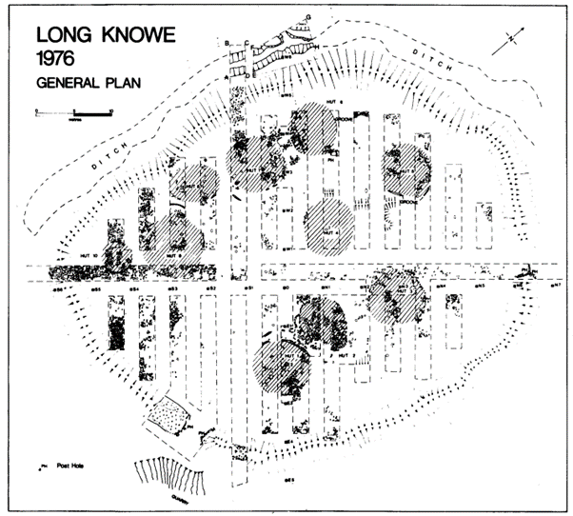

Methods: Excavation; Pollen Analysis
Period(s): Iron Age
Dating: Radiocarbon (2)
Feature(s): Enclosure; Roundhouses; Ditch
Material Culture: Structural Timber (Iron Age)
Ecofacts: Animal Bone; Charcoal (Alnus; Betula); Pollen
Last Update: June 2024 (LA)
Name: Low Clone South
Location: NX 33430 45000
Local Authority: Dumfries and Galloway
NRHE: 62727
LA HER: MDG2399
HES: -
Museum: Dumfries Museum
Reference: Coles, J M 1964 ‘New Aspects of Mesolithic Settlement in South-West Scotland’, Trans Dum Gall Nat Hist Antiq Soc, 41, 67-98
Cormack, W F and Coles, J M 1968 ‘A Mesolithic site at Low Clone, Wigtownshire’, Trans Dum Gall Nat Hist Antiq Soc, 45, 44-72
Summary: Low Clone South on a raised post-glacial shoreline was targeted for excavation in 1965-6 (Cormack and Coles 1968) after lithic analysis (Coles 1964) from coastal fieldwalking over 1962-64. Lithics (1,550+) predominantly flint including cores (platform), rejuv flakes, flakes, blades, retouched tools (including backed blades, burins, scrapers, awls and microliths (30)) and hammerstones were recovered from a buried soil horizon and the fill of three scooped areas. One flat-bottomed scooped or hollow area, 13.7m by 5.4m at widest and up to 0.76m deep, was grid excavated. Arisings from the scoop had formed a bank on the south side. Two large hearths were located outside this scoop, one of which had a possible flue, while ‘occupation soil’ was within the scoop. Stone settings were recorded at levels in the fill and on the base of the scoop along with stakeholes.
Methods: Fieldwalking; Excavation
Period(s): Mesolithic
Dating: -
Feature(s): Stakehole; Hearth; Flue (pos); Hollow
Material Culture: Lithics (Mesolithic); Coarse Stone Artefact; Pottery (Modern); Coin (Modern); Animal Bone (Modern)
Ecofacts: Animal Bone (Burnt); Antler
Last Update: May 2025 (TR)
Name: Mid Gleniron, Glenluce
Location: NX 18733 60963
Local Authority: Dumfries and Galloway
NRHE: 61564; 61594; 61608
LA HER: MDG1619; MDG1649; MDG1663
HES: SM1944
Museum: Dumfries Museum
Reference: Corcoran, John X W P 1963 ‘Excavation of a Chambered Cairn at Mid Gleniron Farm, Wigtownshire (Interim Report)’, Trans Dum Gall Nat Hist Antiq Soc, 41 (1962-63), 99-110
Corcoran, John X W P 1968 ‘Excavations at Mid Gleniron Farm, Wigtownshire, 1963-66’, Trans Dum Gall Nat Hist Antiq Soc, 45, 73-79
Corcoran, John X W P 1969a ‘Excavation of Two Chambered Cairns at Mid Gleniron Farm, Glenluce, Wigtownshire’, Trans Dum Gall Nat Hist Antiq Soc, 46, 29-90
Corcoran, John X W P 1969b ‘Excavation of Two Burial Cairns at Mid Gleniron Farm, Glenluce, Wigtownshire’, Trans Dum Gall Nat Hist Antiq Soc, 46, 91-99
Summary: Students from the University of Glasgow’s Archaeology Department undertook four seasons of excavations at Mid Gleniron Farm between 1963 and 1966. During this time, they excavated the sites of two chambered cairns (Mid Gleniron I and II) and two smaller burial cairns (Mid Gleniron A and B). The two chambered cairns were of multi-period construction, in which an inner cairn or cairns were enclosed in a later structure. They have been identified as being of the Clyde group but the author notes some differences in their construction style.
Mid Gleniron I originated as a small, oval cairn which enclosed a rectangular chamber opening from the north. A second cairn, also containing a rectangular chamber with access from the north, was built close to the entrance of the earlier cairn. The final stage of construction saw the addition of a third lateral chamber between the two and the enclosing of all three chambers, and the earlier cairns, within a long straight-sided cairn. A facade, built of orthostats and dry-stone walling, was also constructed to flank the entrance to the northern chamber. A few small sherds of Neolithic pottery and two flint artefacts were found in the northern part of the cairn. Nine cremations in cinerary urns had been inserted ito the southeast flank of the cairn and appeared to represent secondary use of the cairn (although not of the chambers) during the Bronze Age. Cinerary urns, fragments of a bronze awl and parts of a bronze pin were found in association with these cremations.
Located 120m to the southeast of Mid Gleniron I, Mid Gleniron II originated as a small, oval cairn which enclosed a very small rectangular chamber opening from the east. A larger rectangular chamber, opening from the south, was built up against the edge of the oval cairn and its entrance was flanked by a shallow facade. The composite structure was enclosed within a straight-sided cairn, having a north-south orientation. Sherds of decorated and undecorated Neolithic pottery, some sherds of apparent Bronze Age date and flint artefacts were found. The Bronze Age pottery might suggest that the terminal chamber was re-used in this period.
Mid Gleniron A was a burial cairn positioned immediately to the south of Mid Gleniron I and probably dates from the Bronze Age. It was originally believed to be part of a single structure with Mid Gleniron I but excavation revealed them to be separate. Mid Gleniron A was a much disturbed circular cairn in which a capping of small stones covered a basal layer of larger boulders, arranged in either an annular or a penannular setting. In the centre remains were found of cremated human bone, possibly belonging to a single individual, and perhaps contained in a cinerary urn.
Mid Gleniron B, another burial cairn, sat approximately 14m to the south-southwest of Mid Gleniron II. A small closed chamber, probably built of opposed orthostats and opposed drystone walling, was set at the centre of a circular cairn of large stones. The only artefacts, a flint scraper and a few very small fragments of featureless pottery, did not allow the construction of the cairn to be dated, but it was suggested that it may have been contemporary with the neighbouring chambered cairns, Mid Gleniron I and II.
Methods: Excavation
Period(s): Neolithic; Bronze Age
Dating: -
Feature(s): Cairns; Chambered Cairns; Cremations; Pits
Material Culture: Flints; Metal Artefacts (Bronze Age); Pottery (Neolithic; Bronze Age); Quartz
Ecofacts: Human Bone; Human Bone (Burnt)
Last Update: August 2024 (CW)
Name: Monamore, Arran
Location: NS 01753 28888
Local Authority: North Ayrshire
NRHE: 40086
LA HER: 4669; 5457
HES: SM403
Museum: Hunterian Museum
Reference: MacKie, Euan W 1966 ‘New excavations on the Monamore Neolithic chambered cairn, Lamlash, Isle of Arran, in 1961’, Proc Soc Antiq Scot, 97, 1-34
Summary: The site at Monamore consists of a Neolithic chambered cairn of the Clyde group, also known as Meallach’s Grave. Earlier excavations by Bryce cleared out the burial chamber, but it was excavations undertaken by MacKie in 1961 that produced more detailed findings. The cairn has been greatly robbed and its edges are indefinite, the whole area now being turf-covered. The cairn material remains about 3ft (0.91m) high around the chamber. It had been more or less trapezoidal about 45ft (13.7m) long from the portal stones, widening to a maximum width of about 35ft (10.7m) at 14ft (4.3m) behind the facade. A cutting running southeast from the centre of the chamber showed several slabs that may have fallen from the kerb of dry-stone walling at the edge of the cairn. The cairn was composed of large irregular stones and earth. The Monamore cairn was originally thought to possess only the vestige of a forecourt facade but the 1961 excavations revealed an impressive facade at the southwest end of the cairn. It measures 26ft 9ins (8.15m) across, consisting of eight orthostats set in a shallow and somewhat irregular curve about 3ft 6ins (1.07m) deep. They were linked by dry walling, still standing up to 2ft 4ins (0.71m) high. A thick deposit of grey earth accumulated in the forecourt, to a depth of 2-3ft (0.6-0.9m) against the facade. In it were 21 spreads of charcoal, and many scattered fragments at varying depths. A sillstone 1ft 2ins (0.35m) deep, was firmly wedged between the portals. In front of the sillstone was a small paved area. Over the grey earth was a deliberate blocking of stones in brown earth; its upper surface formed a rough pavement. Two radiocarbon dates were obtained from charcoal in the grey soil deposits. The earlier, from near the base of the deposit, gave a date of 4350 to 3500 cal BC, the later, laid down shortly before the blocking, gave a date of 3400 to 2300 cal BC. This sequence of deposits allowed the few artefacts found to be placed in chronological order. Some sherds of plain, bag-shaped vessels dated from the construction of the cairn while a sherd of slipped, fluted Lyles Hill ware was in the forecourt deposits and therefore later.
Methods: Excavation; Pollen Analysis
Period(s): Neolithic
Dating: Radiocarbon (2)
Feature(s): Chambered Cairn
Material Culture: Lithics; Pottery (Neolithic); Glass; Quartz
Ecofacts: Charcoal (Betula; Quercus; Sorbus); Pollen
Last Update: October 2024 (MM)

Name: Monkton
Location: NS 35682 28167
Local Authority: South Ayrshire
NRHE: 332962
LA HER: 96728; 4660; 4865
HES: -
Museum: ?
Reference: Rennie, Christine 2015 ARO14: Pits, pots and pitchstone: excavation of a multi-phase site at Main Street, Monkton, Archaeology Reports Online
Summary: Excavations were carried out in advance of a housing development at Main Street, Monkton, Ayrshire by GUARD Archaeology. The excavation was preceded by a trial trench evaluation that indicated the presence of prehistoric and medieval and post-medieval features. Artefacts recovered from the site, along with radiocarbon dates from secure contexts, indicate phases of occupation from the early Mesolithic, early to late Neolithic, the early Bronze Age and the Iron Age. The earliest identifiable activity on the site was an accumulation or deposit of charcoal-rich material dated to the Mesolithic that overlay a circular pit. The evidence for Neolithic material was recovered from several pits, some of which were identified as fire pits. The pottery recovered from these pits indicated that food preparation was occurring, either for domestic consumption or for ritual feasting, during this period. Three pits showed evidence for re-use into the Bronze Age, with the date range of artefacts in at least one of them suggesting that it had been re-opened for the purpose of deposition. The single structure that could be identified was an Iron Age ring-groove roundhouse with an internal post circle. This feature had been truncated by medieval and post-medieval cultivation furrows.
The excavation and post-excavation analysis of the features at Main Street, Monkton in conjunction with the known lithic artefact scatters in the locality indicates that settlement was first established here from at least the first quarter of the 7th millennium BC until the early 1st millennium AD. The disparate nature of the excavated features may be an indication that early prehistoric settlement was intermittent, with activity during the early 7th millennium BC, the mid-4th millennium BC and later 3rd millennium BC being identified. The pottery vessels recovered during the fieldwork are significant indicators not only for continued occupation of the site but for highlighting the repeated acts of deposition within specific pits. The lithic assemblage indicates that Monkton was part of an inter-regional exchange network involving imported Yorkshire flint, and also demonstrates the use of local raw material resources.
Methods: Evaluation; Excavation
Period(s): Mesolithic; Neolithic; Bronze Age; Iron Age; Medieval; Post-Medieval; Modern
Dating: Radiocarbon (9)
Feature(s): Cultivation; Ditches; Drains; Hearths; Pits; Postholes; Roundhouse
Material Culture: Lithics (Mesolithic; Neolithic); Pottery (Neolithic; Bronze Age; Medieval; Modern); Quartz
Ecofacts: Cereal (Avena; Hordeum; Triticum); Charcoal (Alnus; Betula; Corylus; Fraxinus; Salix; Quercus; Ulmus); Nutshell (Corylus); Unidentified Bone (Burnt)
Last Update: October 2024 (MM)
Name: Montfode, Ardrossan
Location: NS 22800 44100
Local Authority: North Ayrshire
NRHE: 269034
LA HER: 22911
HES: -
Museum: ?
Reference: Hatherley, Candy 2010 ‘Into the west: excavation of an Early Christian cemetery at Montfode, Ardrossan, North Ayrshire’, Proc Soc Antiq Scot, 139, 195-211
Summary: A previously unknown cemetery of 60 graves, a mix of long cists, partial cists and simple earth-dug graves, some within a sub-circular enclosure, was located and excavated on the banks of the Montfode Burn near Ardrossan. The work was carried out in 2003, in advance of the construction of the A78 Ardrossan, Saltcoats and Stevenston bypass, funded by Transport Scotland and managed by Historic Scotland. The cemetery appears to have had multiple phases of use from the 6th century to the late 8th or 9th century and fits the model of a being a small enclosed community cemetery. Although frequent throughout the southeast of Scotland, few Early Christian cemeteries have been identified in the southwest.
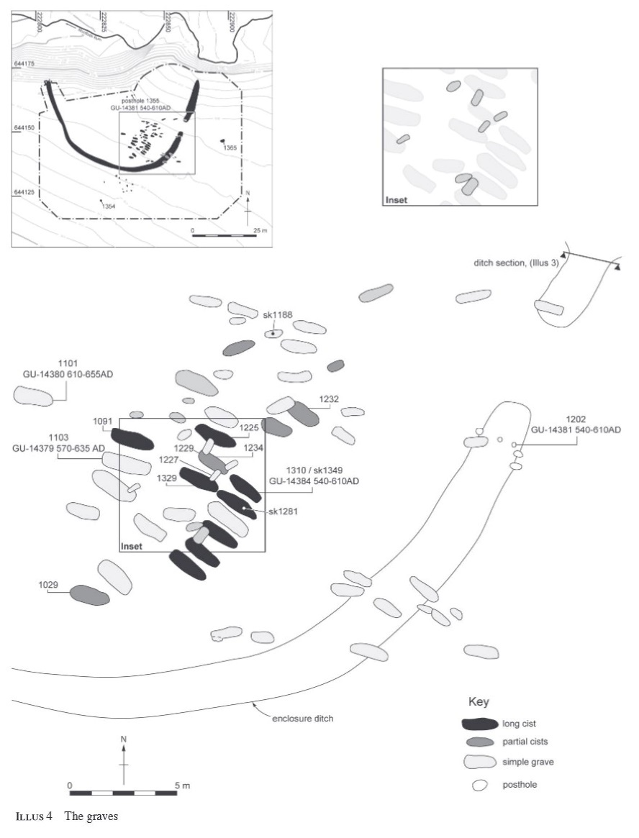

Methods: Aerial Photography; Evaluation; Excavation
Period(s): Bronze Age; Early Medieval
Dating: Radiocarbon (6)
Feature(s): Enclosure; Ditch; Long Cist; Cists; Burials; Postholes; Pits
Material Culture: -
Ecofacts: Human Bone; Cereal (Hordeum); Charcoal (Alnus)
Last Update: June 2024 (LA)
Name: Moss Raploch, Clatteringshaws
Location: NX 55300 77647
Local Authority: Dumfries and Galloway
NRHE: 63777
LA HER: MDG3375
HES: -
Museum: ?
Reference: Condry, J and Ansell, Michael 1978 ‘The Excavation of a Hut-Circle at Moss Raploch, Clatteringshaws’, Trans Dum Gall Nat Hist Antiq Soc, 55 (1977-78), 105-113
Summary: Two enclosures were discovered in 1974 during drainage operations at Clatteringshaws Reservoir. Due to the danger of further erosion, Enclosure 1 was excavated that same year, however, Enclosure 2, which was recorded on the 1852 Ordnance Survey map as ‘pen’, was not excavated. The excavation revealed a roundhouse that had a similar layout to many houses of the ‘Tyne-Forth’ group. It shared such common features as a paved causeway associated with a raised threshold stone and a southeast facing entrance; the hearth was similarly slab-built and the rear of the hut was also raised and slightly separated. Certain features of Moss Raploch differed from the excavated examples of the ‘Tyne-Forth’ group, in particular, the traces of external structures and postholes set close inside the wall. Interestingly, the artefacts recovered from the structure are indicative of accidental deposition related to the settlement of Moss Raploch, including glass ring fragments and a whetstone. The ring fragments gave a tentative date of 1st or 2nd century AD and further placed Moss Raploch within the period that stone-built roundhouses were widespread in the Tyne-Forth Province.
Methods: Excavation; Pollen Analysis
Period(s): Iron Age
Dating: -
Feature(s): Enclosure; Hearth; Postholes; Roundhouse; Causeway
Material Culture: Glass (Iron Age); Coarse Stone Artefact; Lithic
Ecofacts: Animal Bone (Burnt); Charcoal (Betula; Corylus; Populus; Salix; Fraxinus); Pollen
Last Update: June 2024 (LA)
Name: Outerwards, Largs
Location: NS 23162 66596
Local Authority: North Ayrshire
NRHE: 41272
LA HER: 5847
HES: SM4377
Museum: Hunterian Museum
Reference: Newall, Frank 1976 ‘The Roman signal fortlet at Outerwards, Ayrshire’, Glasgow Archaeol J, 4, 111-123
Summary: Excavations took place on a Roman fortlet near Outerwards, Largs by Frank Newall in July 1970. The fortlet lay on a narrow ridge traversed by an alleged Roman Road which bifurcated to pass around the fortlet. It consisted of a sub-square enclosure within a low turf rampart, with two entrances, and an irregular outer ditch interrupted by a crossing on its SSW side. The excavations revealed two periods of occupation, both Antonine. In the first, a 12ft 6ins (3.8m) wide rampart, solidly kerbed externally but merely delimited internally for the adaptation of a turf bank at the rear, was interrupted on the south to receive a gateway 7ft 6ins (2.28m) wide between posts of which there were probably three opposed pairs. Only 3ft (0.91m) from the rampart on either side of a 7ft 6ins (2.28m) wide street lay two timber-framed buildings. These measured 36ft (11m) north/south by 15ft (4.6m) wide on the west side of the street, and 12ft (3.65m) wide on the east side. The destruction of this fortlet was so thorough that the entire interior was covered by a scatter of burnt wattle and daub from the 'barracks' walls, the rampart was slighted on both faces, the gateway was entirely pulled down – one gatepost had been snapped across – and the collapse of the rampart on the west side had possibly led to the loop road on that side being washed out by flooding. In the second occupation, which followed within a few years, a similar plan was adopted. The rampart reconstruction produced an unusual flattened curve at the rampart ends on each side of the entrance due to the addition of turf banks on both faces. The buildings now measured 35ft (10.7m) north/south by 14ft (4.3m) on the west and 14ft (4.3m) wide on the east. On the east the new loop road was added. From the primary floor of the west barracks came neck and rim sherds of an Antonine I olla, the only closely dateable vessel of 13 represented in sherds, six from the primary and seven from the secondary floors. Re-used as kerbing behind the gateway, were fragments of at least three Andernach lava querns.
Methods: Excavation
Period(s): Roman
Dating: -
Feature(s): Buildings; Ditch; Hearth; Postholes; Quarries; Road; Ramparts
Material Culture: Coarse Stone Artefacts; Daub (Roman); Lithics; Metal Artefacts; Pottery (Roman); Structural Timber (Roman)
Ecofacts: -
Last Update: October 2024 (MM)
Name: Park of Tongland, Kirkcudbright
Location: NX 69963 56083
Local Authority: Dumfries and Galloway
NRHE: 64017
LA HER: MDG3612
HES: SM1039
Museum: ?
Reference: Russell-White, Christopher J, Lowe, Christopher E and McCullagh, Roderick P J 1992 ‘Excavations at Three Early Bronze Age Burial Monuments in Scotland’, Proc Prehist Soc, 58, 285-323
Summary: Park of Tongland, regarded as a four-poster stone circle, was excavated after the fall of a standing stone. A total of thirteen pits were excavated: four contained cremated human bone, two of which had associated collared urns. The excavation of Park of Tongland showed the monument to be of sequential rather than single-phase construction. The earlier phase consists of the digging of a series of burial pits and the erection of two orthostats. The second phase consisted of the construction of a cairn and the erection of a further two orthostats but only after one of the first standing stones had fallen. Essentially, the Park of Tongland was a flat cemetery marked by two standing stones which evolved into a kerbed cairn with additional standing stones. A series of radiocarbon dates fell within a short date range of 1480–1530 cal BC indicating that the site was a multi-sequence but not a multi-period site. Despite being identified as a ‘four-poster’ circle, the excavation could not demonstrate that the four standing stones had ever been erect at the same time. The incompleteness of the burials themselves indicated that the token deposition of part of the cremation was all that was deemed necessary in the burial rite. The findings of the excavation also implied that cremation had occurred in the immediate vicinity.
Methods: Excavation; Soil Micromorphology
Period(s): Bronze Age
Dating: Radiocarbon (9)
Feature(s): Cairn; Cremations; Pits; Standing Stones; Stone Circle
Material Culture: Pottery (Bronze Age); Bone Artefact
Ecofacts: Human Bone (Burnt); Animal Bone (Burnt); Charcoal (Corylus; Fraxinus; Quercus)
Last Update: October 2024 (MM)

Name: Perceton, Irvine
Location: NS 35330 40770
Local Authority: North Ayrshire
NRHE: 215293
LA HER: 42976
HES: -
Museum: ?
Reference: Stronach, Simon 2004 ‘The Evolution of a Medieval Scottish Manor at Perceton, near Irvine, North Ayrshire’, Med Arch, 48, 143-166
Summary: A housing development within the former grounds of Perceton House on the outskirts of Irvine led to the discovery of a 12th-century stockaded farmstead without obvious excavated parallels. At that time, it is likely that the Perceton lands were run by a steward, resident in the farmstead in the name of an absentee landowner. On a general note, it is suggested that this type of site may be common but rarely visible, except as a cropmark, which without excavation may be mistakenly classified as prehistoric. In the early 14th century, the land became the principal residence of a member of the Stewart family. The old stockade was removed, and a moat excavated, probably around a new manor house. A corn-drying kiln was also identified from this phase. In the late 1400s following a period of absorption in larger estates the site again became a principal residence, to one Ninian Barclay. This resulted in the building of a new mansion, mainly lying to the south of the excavated area. This was demolished in the 1720s, when another new owner constructed the present Perceton House.
Methods: Monitoring; Excavation
Period(s): Medieval
Dating: Radiocarbon (6)
Feature(s): Cropmark; Palisade; Moat; Postholes; Ditch; Corn-Drying Kiln; Wall; Pits
Material Culture: Pottery (Medieval; Post-Medieval); Industrial Residue; Metal Artefacts (Medieval); Wooden Artefacts (Medieval); Clay Tobacco Pipes (Post-Medieval); Roofing Slates; Glass (Post-Medieval); Daub
Ecofacts: Cereal (Avena; Hordeum; Linum; Secale; Triticum); Nutshell (Corylus); Weed Seeds; Charcoal
Last Update: August 2024 (LA)

Name: Polmaddy, New Galloway
Location: NX 59004 87795
Local Authority: North Ayrshire
NRHE: 63815
LA HER: MDG3413
HES: SM5391
Museum: ?
Reference: Yates, Michael J 1978 ‘The Excavations at Polmaddy, New Galloway’, Trans Dum Gall Nat Hist Antiq Soc, 53 (1977-78), 133-146
Summary: The settlement or fermtoun of Polmaddy, New Galloway was first mentioned in a document of 1505 and was deserted at some point in the early 19th century. The settlement was surveyed and partially excavated. While the settlement is ruinous, it is still possible to determine the plan though many of the structures could have changed several times with earlier buildings potentially completely removed to provide space or material for their successors. The survey identified 23 buildings, including houses, a byre, an inn and stable, five kilns, a mill with associated lade and mill pond, a pack road and a field system. The excavation focused on the western end of one of the longer buildings (Building No. 9) and one of the corn-drying kilns and its associated kiln barn (Building No. 17). The long building was identified as having two entrances with evidence of cruck slots for a roof. Excavations revealed that Building No. 9 was originally longer and had been reduced when the yard was built for the structure. A potential hearth was identified within the interior of Building No. 9 providing credence to the theory of the structure being used for both human and animal inhabitants. A ditch and pit were identified underlying the western end of the southern wall which potentially represents an earlier phase of occupation; however, further excavation would be required for confirmation. The corn-drying kiln was identified as a funnel shaped kiln that was partly built into a natural spur with much of the upper portions robbed of stone. The kiln barn was identified as large boulders that were only a single course high. A paved floor area was identified in the interior, yet it is believed to potentially represent supports for a wooden floor above ground level. The artefacts recovered were largely from the late 18th to early 19th century date, with a glass handle thought to be mid-18th century. It is thought that all artefacts recovered were roughly contemporary with the site’s abandonment. Much of the Polmaddy Settlement was left unexcavated and as such the true extent of the settlement, nature of its abandonment and further information related to the land improvements of the 18th century are still hidden beneath the turf and soil.
Methods: Excavation
Period(s): Post-Medieval; Modern
Dating: -
Feature(s): Buildings; Walls; Ditch; Postholes; Pits; Hearth; Corn-Drying Kiln
Material Culture: Pottery (Post-Medieval; Modern); Industrial Residue; Metal Artefacts; Coarse Stone Artefacts; Glass; Clay Tobacco Pipes (Modern); Coin
Ecofacts: Charcoal
Last Update: January 2025 (LA)
Name: Redkirk Point
Location: NY 30210 65100
Local Authority: Dumfries and Galloway
NRHE: 67452; 67463; 67469; 67438
LA HER: MDG7780; MDG7755/7754/7790; MDG7793; MDG7763
HES: -
Museum: Dumfries Museum
Reference: Godwin, H and Willis, E H 1962 ‘Cambridge University Natural radiocarbon Measurements V’, Radiocarbon, 4, 57-70
Truckwell, A E and Williams, J 1967 ‘Mediaeval Pottery in Dumfriesshire and Galloway’, Trans Dum Gall Nat Hist Antiq Soc, 44, 133-174
Jardine, W G 1980 ‘Holocene Raised Coastal Sediments and Former Shorelines of Dumfriesshire and Eastern Galloway’, Trans Dum Gall Nat Hist Antiq Soc, 55, 1-59
Masters, L 1981a ‘A Mesolithic hearth at Redkirk Point, Gretna, Annandale and Eskdale District’, Trans Dum Gall Nat Hist Antiq Soc, 56, 111-114
Cormack, W F 1983 ‘A Flint Blade from Redkirk Point, Dumfriesshire’, Trans Dum Gall Nat Hist Antiq Soc, 56, 92
Summary: For some years before coastal protection works in the late 1970s at Redkirk Point artifacts were recovered as they were eroded from the carse clays and overlying topsoil. The Red Kirk itself, probably built in the late 12th century, fell into the sea in 1675. The site is at the end of an important medieval ford across the upper Solway. Some 363 sherds of medieval pottery collected from the point and held by Dumfries Museum were assessed by Truckwell and Williams (1967, 148-9). A fragment of fused sand and lead silicate found here may indicate a kiln site. Also exposed was a good succession of post-glacial stratification which has been the subject of several papers (including Jardine 1980). A solitary hearth was excavated in 1977 (Masters 1981a) with charcoal providing Mesolithic radiocarbon dates (2). The hearth formed by sandstone pebbles was constructed in a shallow heat-affected hollow in the sand, some 1.03m by 0.65m in plan and 0.25 maximum depth. A thin layer of organic detritus, less than 5mm thick, lay around the southeast edge of the hollow. This was linked by the author to the dark brown to black organic detritus described by Jardine (1980, 7) as sealed the silts of the maximum Holocene marine transgression and dated by Godwin and Wills (1962, 59) by a Mesolithic radiocarbon date (1). No material culture was recovered from the excavation. A flint blade held by Dumfries Museum and found ‘within a few yards’ of the hearth was described by Cormack (1983) as Mesolithic, this was lost before the paper was published.
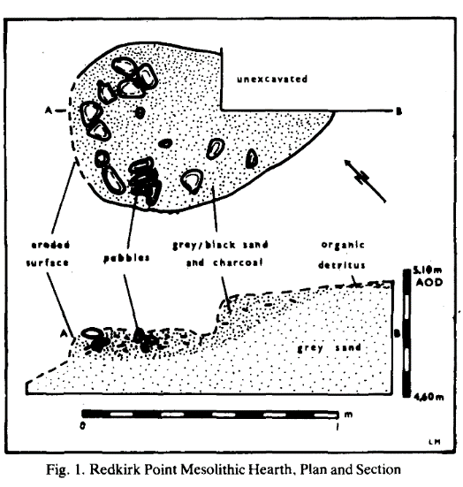
Methods: Fieldwalking; Excavation
Period(s): Mesolithic; Medieval
Dating: Radiocarbon (3)
Feature(s): Hearth; Kiln (pos)
Material Culture: Pottery (Medieval); Lithics (Mesolithic); Industrial Residue (Medieval)
Ecofacts: Pollen; Charcoal (Quercus; Ulmus)
Last Update: June 2024 (TR)

Name: Rowallan Castle
Location: NS 43472 42427
Local Authority: East Ayrshire
NRHE: 42975
LA HER: 1212, 7530
HES: LB12523
Museum: ?
Reference: Ewart, Gordon and Gallagher, Dennis 2009 A Palace Fit for a Laird: Rowallan Castle Archaeology and Research 1998-2008, Historic Scotland: Edinburgh
Summary: The programme of archaeological excavation and survey at Rowallan Castle commenced in 1998 with excavation within the late medieval tower, itself placed on a natural mound. This revealed a Bronze Age burial pit, a series of timber structures and a stone platform. The burial pit contained a layer of cremated human bone and a Food Vessel of around 2300 or 2100 – 1700 cal BC. There was no defined cut for the deposition of burnt bone or the Food Vessel, and it may be that the fill of the pit was laid around the vessel, rather than the vessel being placed at a later date. Traces of at least three episodes of timber buildings pre-dating the stone tower were revealed and radiocarbon dating from contexts associated with two of these structures has suggested construction dates of around 100 BC and 300 BC respectively. Truncation during the construction and conversion of the medieval stone tower removed much of the contextual evidence for the activities represented by the range of timber features and the burial. Natural mounds are common in the glaciated landscape of Ayrshire and the excavated timber structures, whether for ritual or defence, emphasise how such features of the landscape were exploited, obvious foci of human activity.
This excavation, combined with subsequent comprehensive analysis of the upstanding building, has demonstrated the medieval and post-medieval development of the site beginning with a tower house of mid-13th to 15th century date. The south range of the courtyard was established in the late 15th to early 16th century and construction of the Great Hall is identified as the work of Mungo Mure (1513-47). His successor, John Mure, was responsible for the remarkable fore work of the castle, as well as the construction of the gallery, woman house and back work. Historical research has shown that, contrary to generally accepted history, Rowallan was held by the Comyn family in the mid-13th century, not becoming a Mure possession until the latter part of the century. An account is given of the owners of Rowallan, its setting and the economy of the estate.
Methods: Excavation; Pollen Analysis; Soil Micromorphology; Historic Building Recording
Period(s): Bronze Age; Iron Age; Medieval; Post-Medieval
Dating: Radiocarbon (5)
Feature(s): Postholes; Pits; Cremation; Structures; Walls
Material Culture: Pottery (Bronze Age; Post-Medieval); Glass (Post-Medieval; Modern); Coins (Post-Medieval); Metal Artefacts (Post-Medieval); CBM; Clay Tobacco Pipes (Post-Medieval)
Ecofacts: Human Bone (Burnt); Cereal (Triticum; Avena; Hordeum; Secale); Charcoal (Corylus); Weed Seeds
Last Update: January 2025 (LA)
Name: Rue Farm, Holywood
Location: NX 90862 80952
Local Authority: Dumfries and Galloway
NRHE: 65903
LA HER: MDG6360
HES: -
Museum: Dumfries Museum
Reference: Scott-Elliot, James 1961 ‘A Grain Drying Kiln Rue Farm, Dumfriesshire’, Trans Dum Gall Nat Hist Antiq Soc, 39 (1960-61), 80-82
Summary: A corn-drying kiln was excavated in April 1961 at a site on Rue Farm, 200 yards (182.9m) north of Fourmerkland Tower. The kiln had previously stood within a barn and has been associated with a pottery sherd thought to date to the 15th century. The kiln stands beside an old metalled track to Fourmerkland Tower. Some 200ft (60.9m) from the kiln, and beside a stream, there is a low mound of fragmented small stone and black ash. The kiln consisted of a flagstone pathway with an air duct underneath, a hearth, a stone flue and the stone-lined bowl of the kiln. Three postholes set into the top of the bowl may have represented the supports for roofing over the kiln. The presence of the pottery and the nearby Fourmerkland Tower indicated that the kiln was likely late 15th or early 16th century in date.
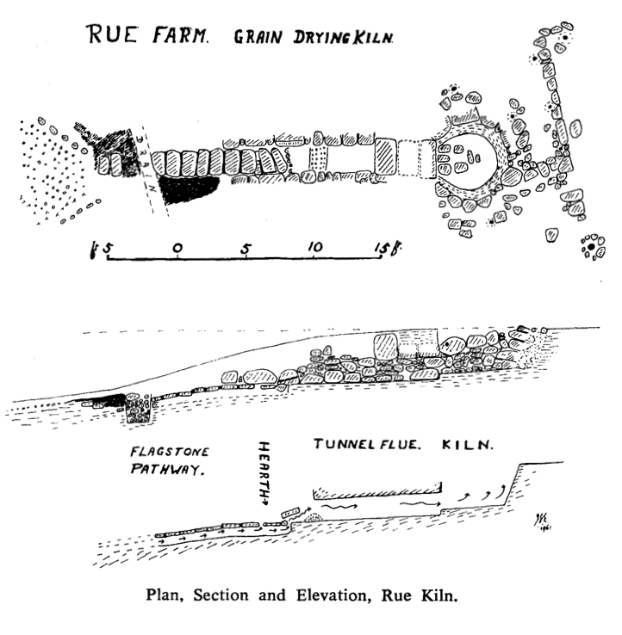

Methods: Excavation
Period(s): Medieval
Dating: -
Feature(s): Corn-Drying Kiln; Flue; Hearth; Postholes
Material Culture: Pottery (Medieval); Glass (Modern); Metal Artefacts
Ecofacts: -
Last Update: September 2024 (MM)
Name: St John’s Tower, Ayr
Location: NS 33381 22021
Local Authority: South Ayrshire
NRHE: 41745
LA HER: 6316
HES: LB21766
Museum: ?
Reference: Perry, David 2012b ‘St John’s Tower 8C’ in Perry, David Excavations in Ayr 1984-1987: 8-22. Ayr Archaeol Nat Hist Soc Monograph 37: Ayr
Summary: Excavations were undertaken at St John’s Tower from October 1985 to June 1987, with the purpose of re-excavating the poorly recorded foundations of the church, first uncovered at the end of the 19th century. The aim was to identify and record the period and sequence of its construction, desertion and demolition. The works identified that more than one phase of building activity occurred on the site. The original structure, an aisled nave, was constructed in the 12th century with a subsequent extension and transects added in the 14th century. The tower and south porch were added, and the southern wall of nave rebuilt, in the 15th century, with the tower blocking many of the late 12th-century features of the west wall. The remains of some 50 articulated skeletons (including one double adult burial and one mother and child), and at least 200 disarticulated individuals were recorded. The results from an examination of the skeletons indicated that, in general, the population did not suffer particularly harsh childhood conditions affecting physical development. The development of male children does seem to have been prejudiced by unknown factors, however, resulting in relatively shorter lower limbs. What is striking is the evidence of a physically arduous lifestyle for women as well as men. Women were involved in lifting or carrying heavy loads in adolescence, more so than men, or carrying children on their backs while working.
Methods: Excavation
Period(s): Medieval; Post-Medieval
Dating: -
Feature(s): Animal Burial; Burials; Hearth; Pits; Postholes; Structure; Walls
Material Culture: Bone Artefact (Post-Medieval); Carved Stone Fragments (Medieval); CBM; Clay Mould Fragments; Clay Tobacco Pipes (Post-Medieval; Modern); Coarse Stone Artefacts; Coins (Medieval; Post-Medieval; Modern); Glass (Medieval); Metal Artefacts (Medieval; Post-Medieval; Modern); Pottery (Medieval; Post-Medieval); Roofing Slate (Medieval); Structural Timbers
Ecofacts: Animal Bone; Human Bone
Last Update: January 2025 (LA)
Name: Sannox Quarry, Arran
Location: NS 01491 45490
Local Authority: North Ayrshire
NRHE: 346443
LA HER: 4866; 92171
HES: -
Museum: ?
Reference: Arabaolaza, Iraia 2014 ARO10: The cliff hanging cists; Sannox Quarry, Isle of Arran, Archaeology Reports Online
Summary: The discovery of two Bronze Age cists in a disused quarry in Sannox, Isle of Arran by the landowner and a local resident prompted their rescue excavation by GUARD Archaeology Limited, on behalf of Historic Scotland, under the Human Remains Call-off Contract between 28 March and 5 April 2012. One of the cists contained a human cremation accompanied by a tripartite food vessel and scale-flaked flint knife while the second was empty. A radiocarbon date of 2154–2026 cal BC was obtained from the cremated bone dating it to the early Bronze Age. A charcoal fragment from the second cist was dated to 3520–3368 cal BC; which was thought to correspond to earlier activities in the area. Two modern features were also revealed. The interpretation of the two cists is constrained by the circumstances of their discovery. They may not be contemporary or have the same function, and we do not know how many other cists have been lost to previous quarrying or remain undetected in the area. However, the food vessel is of note because the majority of such pots have been found in eastern Scotland.
Methods: Excavation
Period(s): Bronze Age
Dating: Radiocarbon (2)
Feature(s): Cists; Cremation
Material Culture: Pottery (Bronze Age); Lithic (Bronze Age)
Ecofacts: Charcoal (Betula; Corylus; Quercus); Human Bone (Burnt)
Last Update: October 2024 (MM)
Name: Slewcairn
Location: NX 92390 61420
Local Authority: Dumfries and Galloway
NRHE: 65491
LA HER: MDG5950
HES: -
Museum: ?
Reference: Sheridan, Alison 2023 Lochhill and Slewcairn: completing two important projects by the late Lionel Masters. Unpublished interim report
Summary: Lionel Masters excavated Slewcairn from 1973 to 1981. The excavation revealed a trapezoidal long cairn with a megalithic façade that covered the remains of a burnt-down timber mortuary structure. A paved area was also present at the rear of the mortuary structure. The cremated remains of at least seven individuals were identified in the area of the mortuary chamber. The bones show signs of having been cremated with the flesh still on, and one hypothesis is that the bodies were laid out on the paving to allow partial decomposition before parts were placed in the mortuary chamber. The parts were then cremated when the chamber was deliberately burnt down. Over 360 sherds of Early Neolithic ‘traditional Carinated Bowl’ pottery were recovered and a radiocarbon date places the activity of the mortuary chamber as between 3701 and 3566 cal BC. Beaker pottery was deposited in the forecourt of the cairn prior to (or around the time) of its blocking. A pit beside the cairn, containing a coarse pot, possibly associated with a tiny amount of cremated bone, appears to be the last act likely occurring in the Early Bronze Age.
Methods: Excavation
Period(s): Neolithic; Bronze Age
Dating: Radiocarbon (5)
Feature(s): Long Cairn; Pit; Posthole
Material Culture: Pottery (Neolithic; Bronze Age); Lithics (Neolithic)
Ecofacts: Human Bone (Burnt), Nutshell (Corylus), Charcoal (Betula, Quercus)
Last Update: December 2024 (LA)
Name: Smittons
Location: NX 63520 91740
Local Authority: Dumfries and Galloway
NRHE: 64344
LA HER: MDG3934
HES: -
Museum: Dumfries Museum (1960s finds)
Reference: Ansell, M 1966 ‘Stroanpatrick, scooped settlement; ring cairn’, Discov Excav Scot, 33
Affleck, T 1983 ‘Smittons (Carsphairn p), Enclosure, Mesolithic flints’, Discov Excav Scot, 5-6
Finlayson, B 1989 A Pragmatic Approach to the Functional Analysis of Chipped Stone Tool. Unpublished PhD thesis. University of Edinburgh
Edwards, K J 1989 ‘Meso-Neolithic vegetational impacts in Scotland and beyond: palynological considerations’ in Bonsall, C (ed) The Mesolithic in Europe, papers presented at the third international symposium: 143-155. John Donald: Edinburgh
Edwards, K J 1996 ‘The Contribution of Tom Affleck to the Study of Mesolithic Southwest Scotland’ in Pollard, T and Morrison, A (eds) The Early Prehistory of Scotland: 108-122. Edinburgh University Press: Edinburgh
Summary: In the 1960s, Ansell (1966) excavated within a later turf-banked enclosure (9m by 7.6m) close to the River Ken to expose flint and chert flakes that were assessed as Mesolithic. Then Affleck in 1983 and 1986 (Affleck 1983 and Edwards 1996) carried on the excavation with Mesolithic occupation material found above, on, and below a gravel or pebble surface; this gave two lithic assemblages, the upper and the lower. The assemblage was composed of chert (73%) and flint (25%) pieces that included cores, blades, scrapers, microliths and debitage, with extremely small triangles, crescents and rods (around 10mm by 1.5mm) microlith forms noteworthy. Charcoal fragments, including hazelnut shells (two were dated to 6260 ± 80 bp (OxA-1595) and 5470 ± 80 bp (OxA-1594) (Edwards 1989) were widespread at all levels. Hearths, including a stone-defined hearth on a bluff overlooking the main site, and an arc of stake holes were also recorded. Affleck considered the stratigraphy to indicate a seasonally flooded riverine environment with lithic material moved downslope due to fluvial action. An Iron Age date from birch wood charcoal (1910 ± 100 bp (OxA-1593) is interpreted as coming from burning the ground for clearance. The lithic assemblage was analysed as a case study within a PhD focused on the functional analysis of lithics (Finlayson 1989) quantifying edge damage, striations and polish on the pieces to consider use.
Methods: Fieldwalking; Excavation
Period(s): Mesolithic; Iron Age; Post-Medieval
Dating: Radiocarbon (3)
Feature(s): Hearth (Mesolithic); Stakehole; Enclosure (Post-Medieval)
Material Culture: Lithics (Mesolithic)
Ecofacts: Charcoal; Nutshell (Corylus)
Last Update: May 2025 (TR)
Name: Starr Cottage (Starr 1)
Location: NX 48325 93900
Local Authority: East Ayrshire
NRHE: 63614; 77749
LA HER: 496; 13106
HES: -
Museum: Dumfries Museum (1960s finds); ? (1980s finds)
Reference: Edwards, K J, Ansell, M and Carter, B A 1983 ‘New Mesolithic sites in south-west Scotland and their importance as indicators of inland penetration’, Trans Dum Gall Nat Hist Antiq Soc, 58, 9-15
Affleck, T L 1984 ‘Loch Doon Starr 1 (Straiton p)’, Discov Excav Scot, 33-34
Affleck, T L 1985 ‘Loch Doon Starr 1 (Straiton p)’, Discov Excav Scot, 49
Finlayson, B 1989 A Pragmatic Approach to the Functional Analysis of Chipped Stone Tools. Unpublished PhD thesis in Archaeology. University of Edinburgh
Edwards, K J 1996 ‘The Contribution of Tom Affleck to the Study of Mesolithic Southwest Scotland’ in Pollard, T and Morrison, A (eds) The Early Prehistory of Scotland: 108-22. Edinburgh University Press: Edinburgh
Summary: Lithic scatters at the southwestern end of Loch Doon were reported by Ansell in the 1960s and by Edwards, Ansell and Carter (1983). Trial excavation in 1984 opened four trenches below the normal water level of the loch, on a ridge where peat had been partly water-eroded. These recovered stratified flint (48%) and chert (52%) material including retouched and utilised blades and flakes, triangle and bladelet microliths, cores and a quantity of debitage on an old round surface beneath the peat. Of note is the large number of snapped blade tips found. Areas of burning were recorded, and charcoal was noted at all levels. Whilst evidence indicates final occupation before initiation of local peat formation, there were also indications of occupation at lower, earlier levels. Excavation in 1985 was carried out at the east end of the site ridge overlooking the loch where a previous trial trench had shown knapping spots and heavy lithic concentration. A working area, occupying a hollow, with dark organic occupation soil and a high density of lithic material (chert and flint) was recorded; several stakeholes and small gullies also occurred here. In this trench, three distinct levels of occupation were indicated. Although work was abruptly halted by flooding, it appears that this area of occupation activity is oval, with dimensions of approximately 4m by 7m. Another five smaller trenches were excavated on the ridge, but only slight evidence of occupation was found. Environmental samples were taken from all the trenches with hazel charcoal from a hearth dated to 6230 ± 80 bp (OxA-1596). Two basal peat dates were also sourced (2415 ± 25 bp (GrN-13135) and 2395 ± 25 bp (GrN-13136)). The lithic assemblage was analysed as a case study within a PhD focused on the functional analysis of lithics (Finlayson 1989) quantifying edge damage, striations and polish on the pieces to consider use.
Methods: Fieldwalking; Excavation
Period(s): Mesolithic
Dating: Radiocarbon (3)
Feature(s): Hollow; Lithic Working Site; Hearth; Stakehole; Pit
Material Culture: Lithics (Mesolithic)
Ecofacts: Birch Bark; Charcoal (Corylus)
Last Update: May 2025 (TR)
Name: Townfoot Farm, Glencaple
Location: NY 00296 68294
Local Authority: Dumfries and Galloway
NRHE: 66087
LA HER: MDG6541
HES: -
Museum: ?
Reference: Scott-Elliot, James 1972 ‘An Early Bronze Age Fire Pit at Townfoot Farm, by Glencaple’, Trans Dum Gall Nat Hist Antiq Soc, 49, 20-23
Summary: An Early Bronze Age fire pit was excavated in 1965-6 by Major General James Scott-Elliot. It was first reported by the farmer of Townfoot as a large black patch which appeared after ploughing, on a large shelf of level ground, between 50ft (15.2m) and 100ft (30.5m) OD and some 60 yards (54.8m) from a small stream. Excavations showed that the site comprised a pit, 12ft (3.6m) by 5ft (1.5m) with an average depth of 1ft 2 inches (0.65m) and a heavily metalled track to the south and west. Outside this to the south and west was a stone-cobbled floor with the possible footing of a small wall outside it again. The track curves northwards around the pit and may continue through the north and east to join the section to the south. The pit was filled with a great quantity of wood ash, mixed with stone chips (1 ½ – 2 inches in size) (0.04m – 0.05m). Two stone pounders and a stone hammer, also a pot stone, were recovered from the pit. An uncalibrated radiocarbon date of 1980 bc ±90 was obtained from a sample, low in the pit. It was suggested that the site was used for roasting deer or human cremation, with the latter seen as the more likely. However, no cremated bone was recovered, possibly due to the acidic nature of the soil and possible weathering.
Methods: Excavation
Period(s): Bronze Age
Dating: Radiocarbon (1)
Feature(s): Pit; Postholes; Wall
Material Culture: Coarse Stone Artefacts (Bronze Age)
Ecofacts: Charcoal
Last Update: August 2024 (MM)
Name: Uppercleuch, Annandale
Location: NY 11320 87139
Local Authority: Dumfries and Galloway
NRHE: 66774
LA HER: MDG9112
HES: -
Museum: National Museums Scotland
Reference: Terry, John 1993 ‘Excavation of a Farmstead Enclosure, Uppercleuch, in Annandale, Dumfries and Galloway’, Trans Dum Gall Nat Hist Antiq Soc, 68, 53-86
Summary: Excavation of an Iron Age enclosure near Lockerbie ahead of the upgrading of the A74 to motorway, funded by the Scottish Office Industry Department (Roads Directorate) and Historic Scotland, revealed evidence of an enclosed settlement that appears to be associated predominantly with animal husbandry. Analysis of environmental samples produced a similar picture, which suggests that the site may have supported a pastoral economy. Just over half of the enclosure was excavated revealing the enclosing ditch and bank, a single entranceway, and a roundhouse and cobbled surface within the interior. There is no definitive dating from the excavated material, however, it can be compared to dated Pre-Roman Iron Age and native settlement enclosures of the Border regions, particularly Boonies and Long Knowe in the Eskdale Valley. With half of the aerially identified side being left unexcavated, there is the possibility of further understanding remaining at the site.
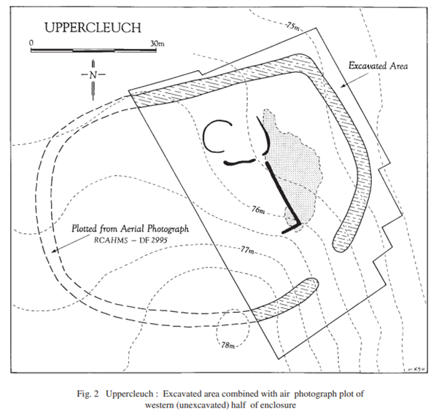

Methods: Aerial Photography; Excavation; Phosphate Analysis; Pollen Analysis
Period(s): Iron Age
Dating: Radiocarbon (2)
Feature(s): Enclosure; Ditches; Roundhouse; Bank; Postholes; Pits; Stakeholes; Hearth
Material Culture: Glass (Roman); Coarse Stone Artefact (Iron Age)
Ecofacts: Charcoal (Corylus; Alnus; Salix); Cereal (Triticum; Hordeum; Avena); Pollen
Last Update: June 2024 (LA)
Name: Wauchope Bridge, Langholm
Location: NY 35620 84110
Local Authority: Dumfries and Galloway
NRHE: 67710
LA HER: MDG10413
HES: -
Museum: Dumfries Museum
Reference: McCracken, Alex 1966 ‘Excavation at Wauchope Bridge, 1965’, Trans Dum Gall Nat Hist Antiq Soc, 43, 152-153
Summary: The western bridge abutment just east of Langholm Manse was partially excavated in August 1965 by Mr Alex McCracken on behalf of the Eskdale and Liddesdale Archaeological Society. On excavation, the abutment was found to consist of two well-built walls, each 18-24 inches (0.45m-0.6m) thick with earth and stones packed between them. The walls were not parallel, the space between them narrowing from 11 feet (3.35m) to about 6 feet (1.83m) as they approached the river. A layer of cobbles was laid on top of the packed earth to form the road surface. These remains were concluded to be of a pack-horse bridge of 17th-century date, incorporating within its causeway bloomery waste, some lead and a piece of medieval pottery. The finds made during the excavation indicate the existence of an early medieval settlement close to the bridge that may be associated with Wauchope Castle.
Methods: Excavation
Period(s): Post-Medieval
Dating: -
Feature(s): Walls
Material Culture: Industrial Residue; Metal Artefact; Pottery (Medieval)
Ecofacts: -
Last Update: October 2024 (MM)
Name: West Cairngaan, Kirkmaiden
Location: NX 13290 31720
Local Authority: Dumfries and Galloway
NRHE: 61092
LA HER: MDG1166
HES: -
Museum: -
Reference: Stevenson, Sylvia 1987 ‘A Short Cist at West Cairngaan, Kirkmaiden, Wigtownshire’, Trans Dum Gall Nat Hist Antiq Soc, 62, 22-31
Summary: A short cist was discovered during ploughing after re-grading of a knoll of glacial sand and gravel on West Cairngaan Farm, Wigtownshire, in April 1986. The site was excavated by Sylvia Stevenson on behalf of the Central Excavation Unit, Ancient Monuments Inspectorate. The slab-lined short cist contained the vestigial remains of a crouched adult inhumation together with traces of cremated bone. There were no associated artefacts. There was no evidence for the chronological relationship between the cremated and inhumed bone and it is possible that they were either contemporary or that the cremated material was earlier, cleared away to make way for the later inhumation. In the light of previous discoveries in the immediate locality, which included another cist found to the southeast in the late 19th century, the site probably formed part of a more extensive cist cemetery. By association, it was seen as probably dating from the early to middle Bronze Age.
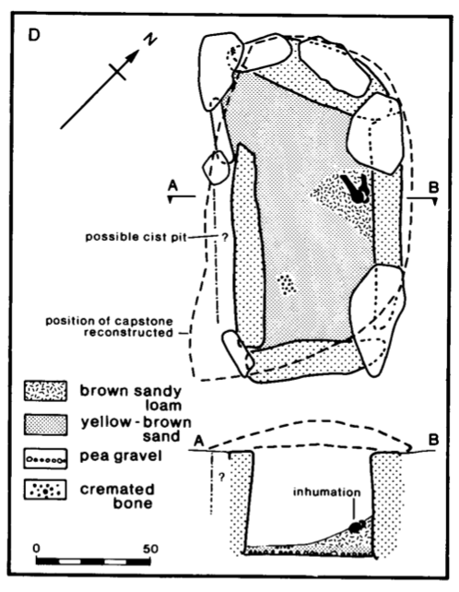

Methods: Excavation
Period(s): Bronze Age
Dating: -
Feature(s): Cremation; Short Cist
Material Culture: -
Ecofacts: Human Bone; Human Bone (Burnt)
Last Update: August 2024 (MM)
Name: Whitecrook Quarry, Glenluce
Location: NX 17180 56690
Local Authority: Dumfries and Galloway
NRHE: 288823
LA HER: MDG9382
HES: -
Museum: ?
Reference: Gordon, Douglas 2009 ‘Excavation of an Iron Age Round House and Associated Palisaded Enclosure at Whitecrook Quarry, Glenluce’, Trans Dum Gall Nat Hist Antiq Soc, 83, 23-41
Summary: The remains of an unenclosed prehistoric settlement were identified during a series of archaeological works that took place in advance of sand extraction in 2006. Rathmell Archaeology carried out the ensuing excavations on behalf of Barr Ltd. Two ring groove houses were identified, along with a palisaded enclosure dating from the Late Bronze Age to the Early Iron Age, and a series of unassociated negative features. While radiocarbon dates showed evidence of further activity from the Neolithic to the Early Bronze Age, no other coherent structures were identified. The findings of the excavation represent the remains of an unenclosed settlement occupied at some time during the Late Bronze Age to the Early Iron Age, which may help to elucidate the prehistoric settlement pattern in the southwest of Scotland.
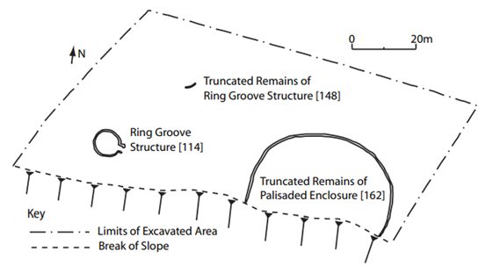

Methods: Evaluation; Excavation
Period(s): Neolithic; Bronze Age; Iron Age
Dating: Radiocarbon (5)
Feature(s): Roundhouse; Posthole; Hearth; Stakeholes; Ditch; Pit; Enclosure
Material Culture: Lithics; Pottery (Bronze Age; Iron Age)
Ecofacts: Charcoal (Betula; Corylus); Cereal (Hordeum)
Last Update: June 2024 (LA)

